**TO DO APPLICATION MANAGEMENT STSTEM MULTI TIER ARCHITECUTRE USING AMAZON WEB SERVICES**

**Introduction**

This document outlines the architecture, setup, and key operational procedures for a multi-tier To-Do application built on Amazon Web Services (AWS). The system is designed to be scalable, secure, and highly available, utilizing a range of AWS services to manage the frontend, backend, and database layers.

**Core Architecture Overview**

The To-Do application follows a three-tier architecture, separating the application into distinct layers.

* **Frontend Layer**: This layer is comprised of an EC2 instance that serves as a web server. It hosts the application's user interface, including HTML, CSS, and JavaScript files, and is responsible for presenting the To-Do list to the user.
* **Application Layer**: This layer uses EC2 instances to run a Python backend. Its primary function is to handle the business logic of the application, such as adding, deleting, and marking tasks as done. It communicates with the database layer to manage the task data.
* **Data Layer**: This is the final layer, featuring an **Amazon RDS DB** that stores all the tasks. The database manages the persistence of tasks, including adding new tasks and deleting completed ones.

**AWS Services Utilized**

The project leverages several AWS services to create a robust and scalable infrastructure.

* **Networking**: **Amazon VPC** creates a secure, isolated network for all resources, with security groups for secure internet and internal communication between servers.
* **Amazon Route 53** acts as the DNS service, routing user requests to the application.
* **Compute & Scaling**: **Amazon EC2 instances** serve as the web and application servers.
* **Amazon Auto Scaling Groups** automatically adjust the number of instances in the web and app layers to handle varying traffic loads, ensuring high availability and performance.
* **Load Balancing**: **Load balancers** distribute incoming web traffic across multiple EC2 instances, preventing any single server from being overwhelmed. The project uses an **Internet-facing Application Load Balancer** for the web servers and an **Internal Application Load Balancer** for the application servers.
* **Database**: **Amazon Aurora and RDS** provide a managed and scalable relational database for storing application data.
* **Security & Monitoring**: **Amazon Certificate Manager** provides SSL/TLS certificates for secure HTTPS connections.
* **Amazon CloudWatch:** monitors the health and performance of the infrastructure
* **Amazon SNS:** is used for sending notifications based on predefined alarms.

**Multi Tire Architecture Group Diagram:**

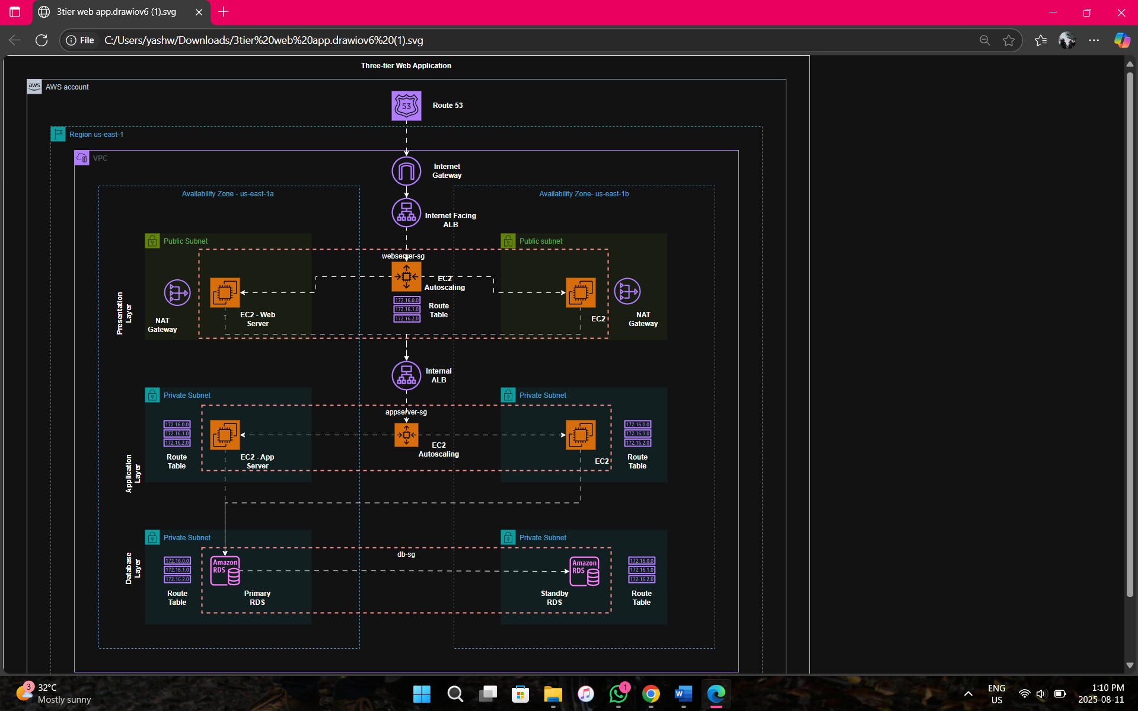

**Multi Tire Architecture Modified Diagram:**

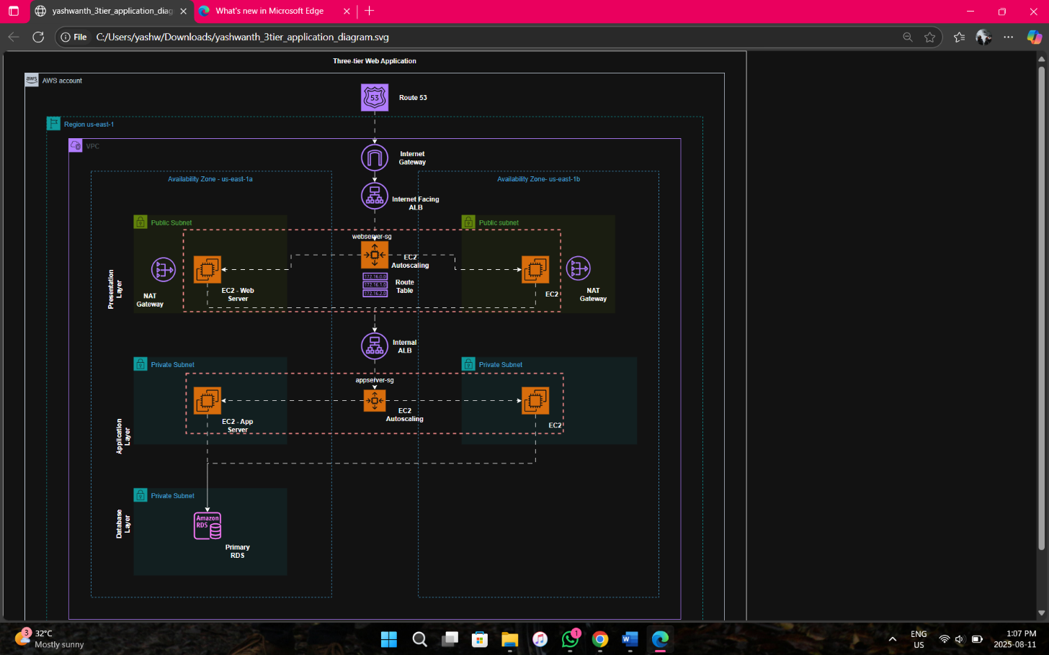

**Phase 1: Purchasing Domain**

**Purchase a domain from GoDaddy website**

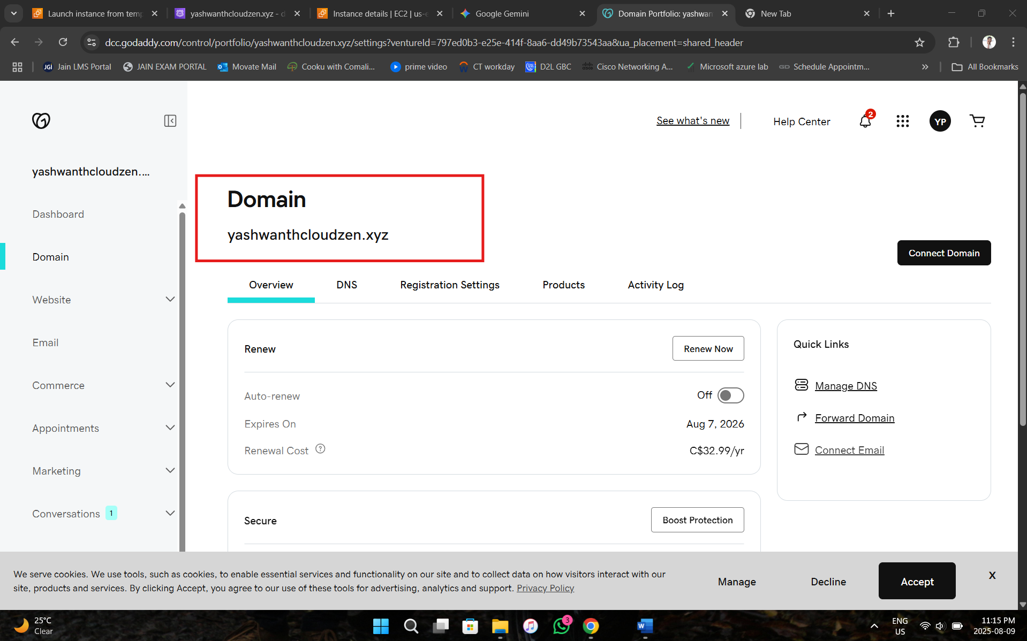

**Phase 2: Setup VPC, Subnets, Route Tables**

1. **Create a VPC**
   * CIDR block: 10.0.0.0/16
2. **Create Subnets**
   * Public Subnet 1 (Web): 10.0.1.0/24
   * Public Subnet 2 (App): 10.0.16.0/20
   * Private Subnet 1: 10.0.128.0/20
   * Private Subnet 2: 10.0.20.0/24
   * Private Subnet 3: 10.0.160.0/20
   * Private Subnet 4: 10.0.176.0/20
3. **Internet Gateway**
   * Attach to VPC
4. **Route Tables**
   * Public route table → 0.0.0.0/0 → IGW
   * Associate with Web & App subnets
5. **Create a VPC**

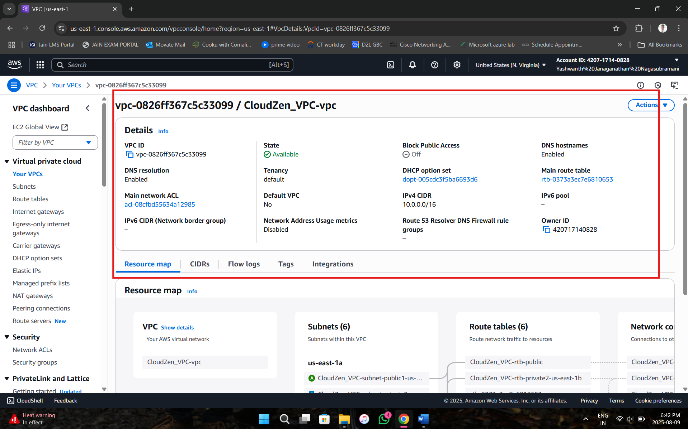

1. **Subnets:**

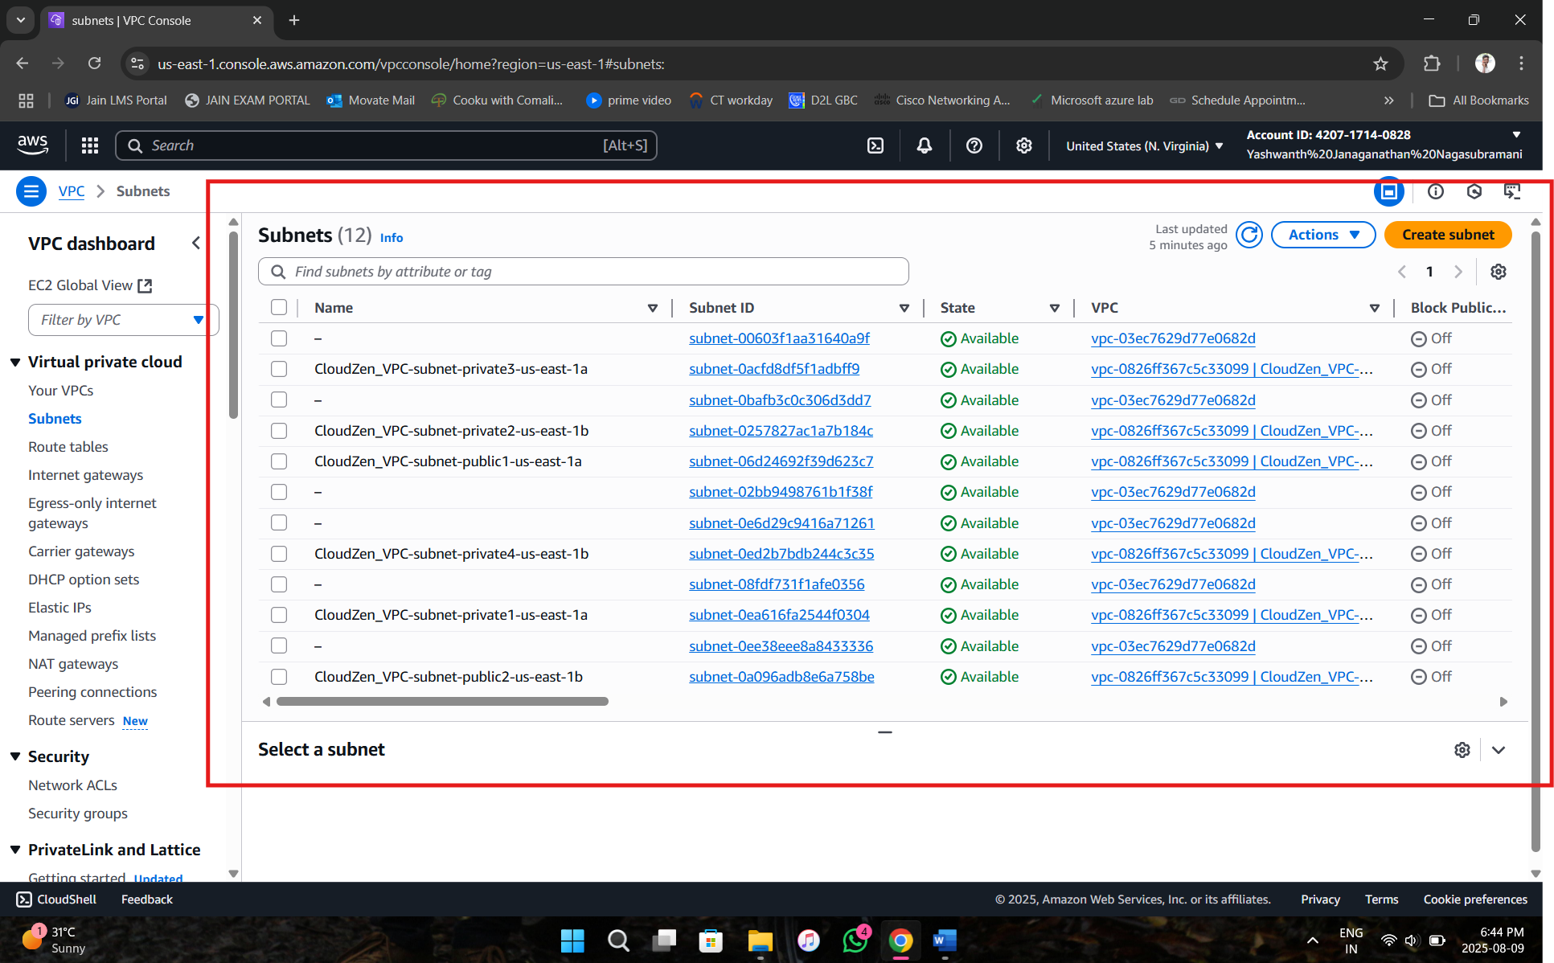

1. **Internet Gateway**

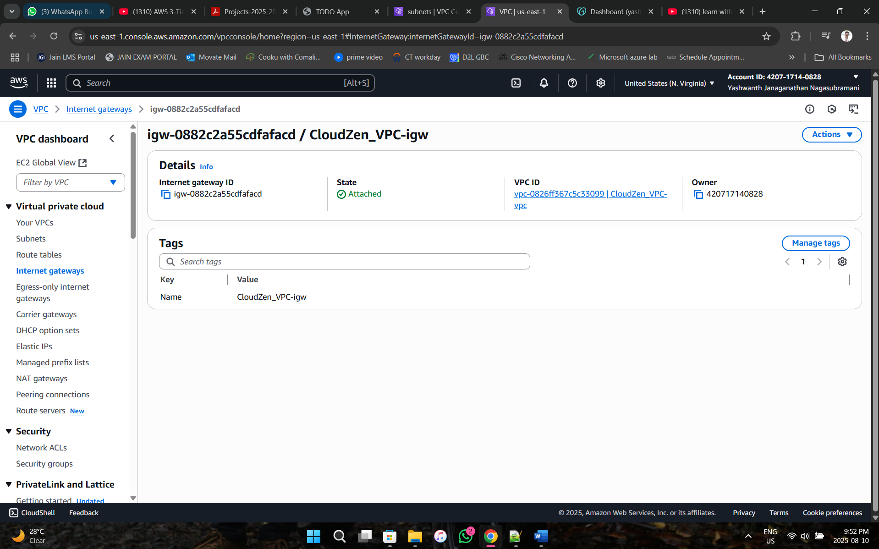

1. **Route Tables associated with Public subnet 1**

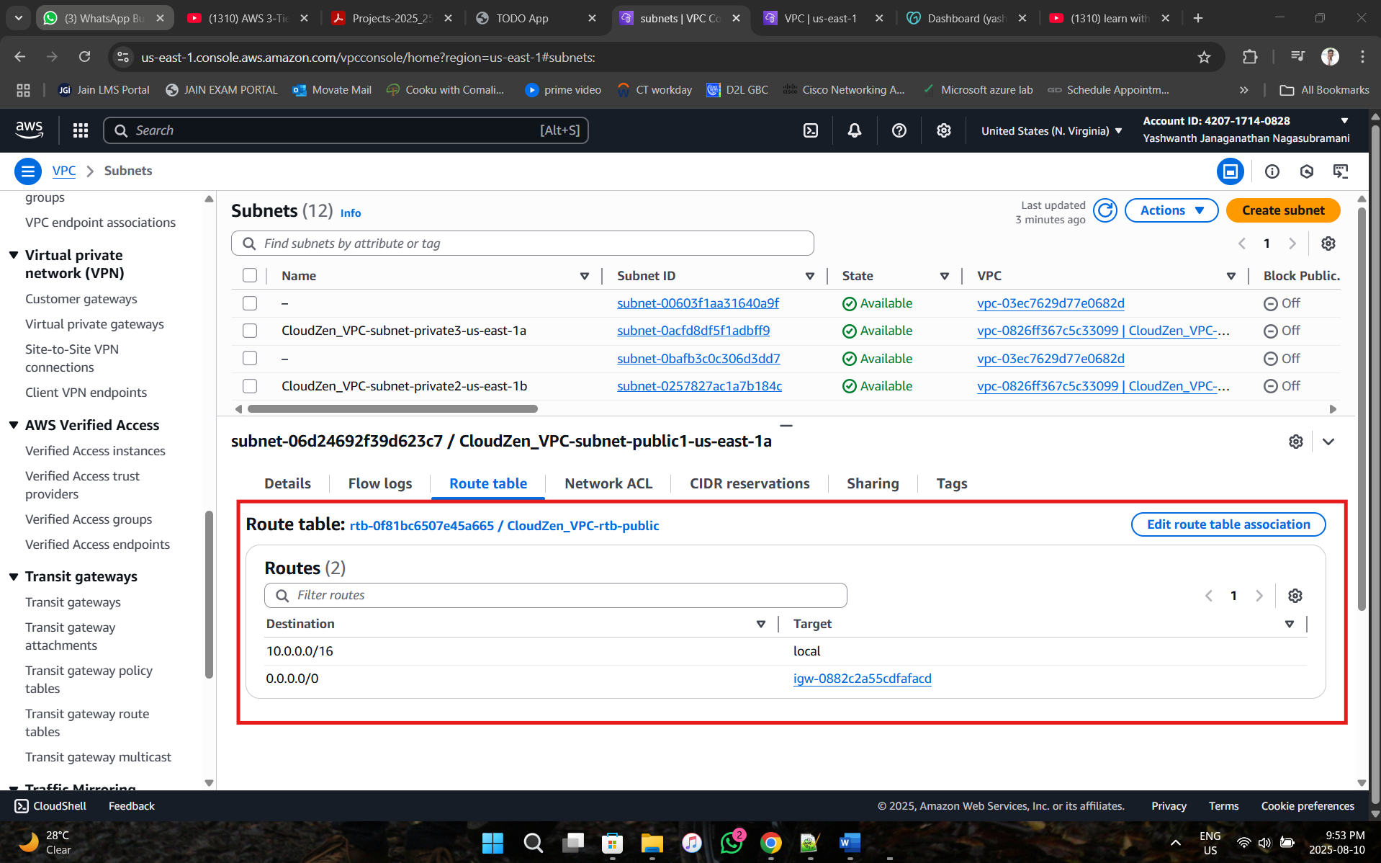

**Phase 3: Create Security Groups**

1. **Internet Gateway Security Group**

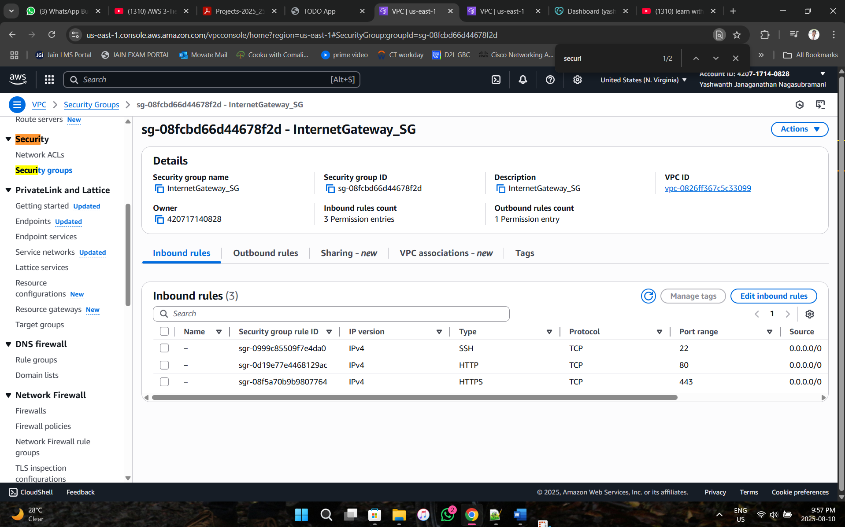

1. **Webserver Security Group**

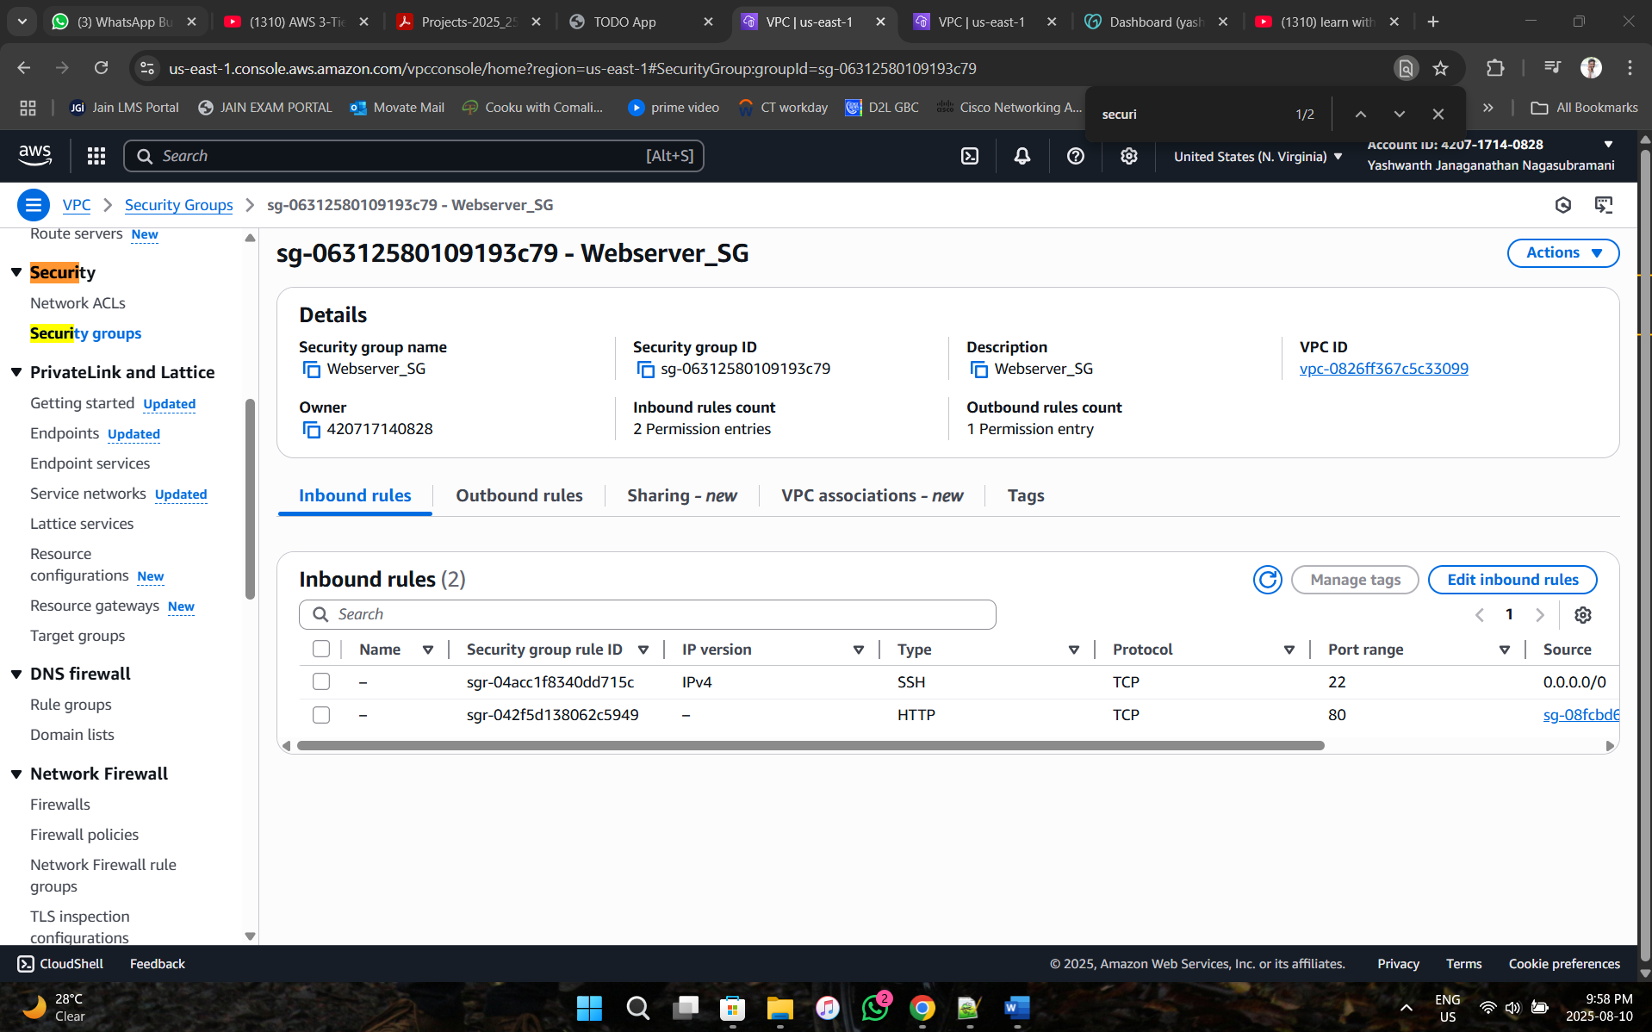

1. **Internal Elastic Load Balancer Security Group**

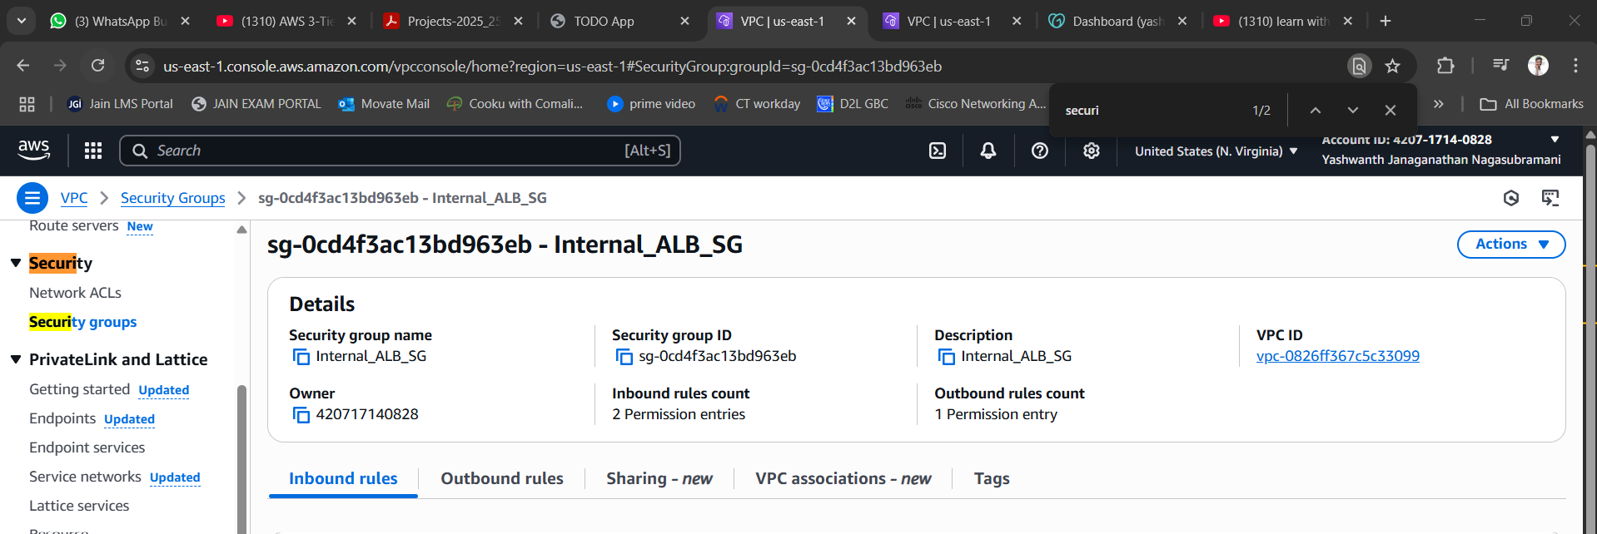

1. **AppServer Security Group**

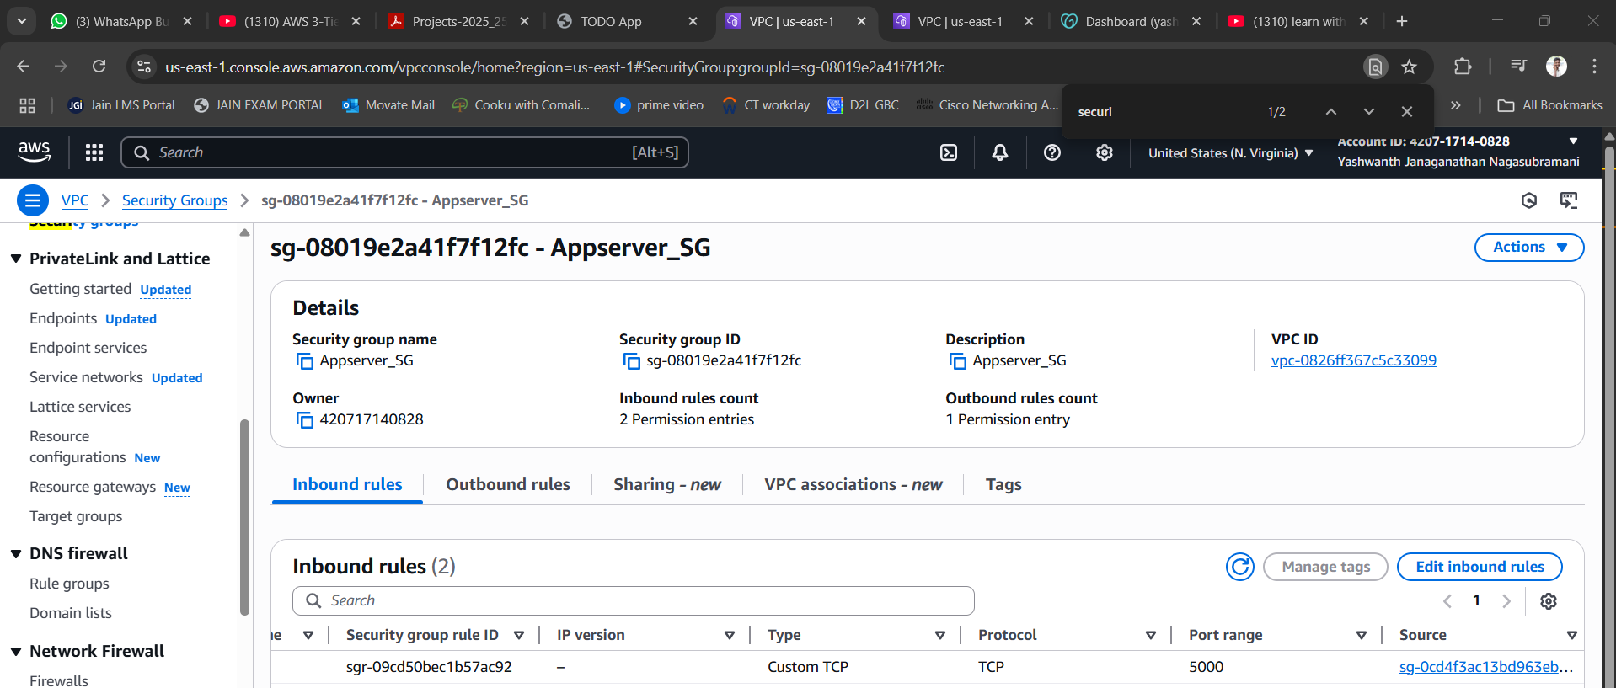

1. **DB Security Group**

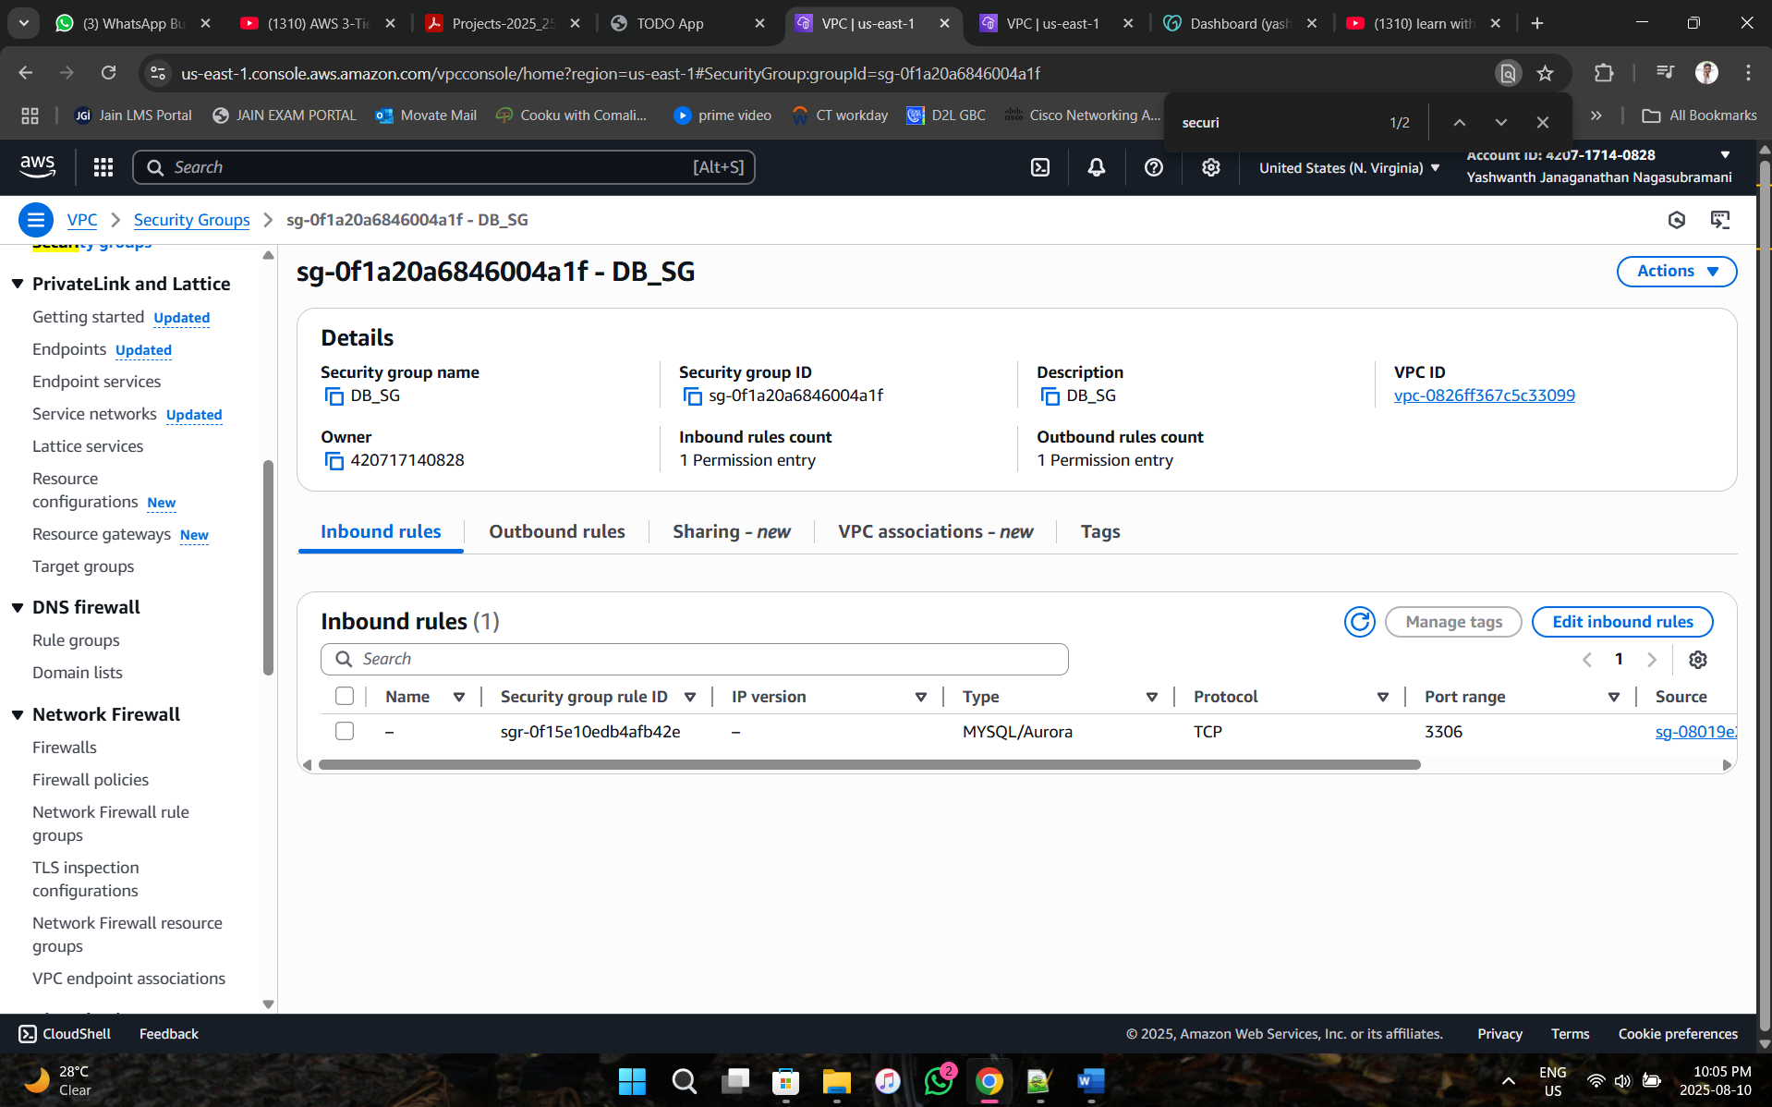

**Phase 4: Create Route 53 Hosted Group and attach Nameservers to Godaddy Domain**

1. **Create Route 53 Hosted Group**

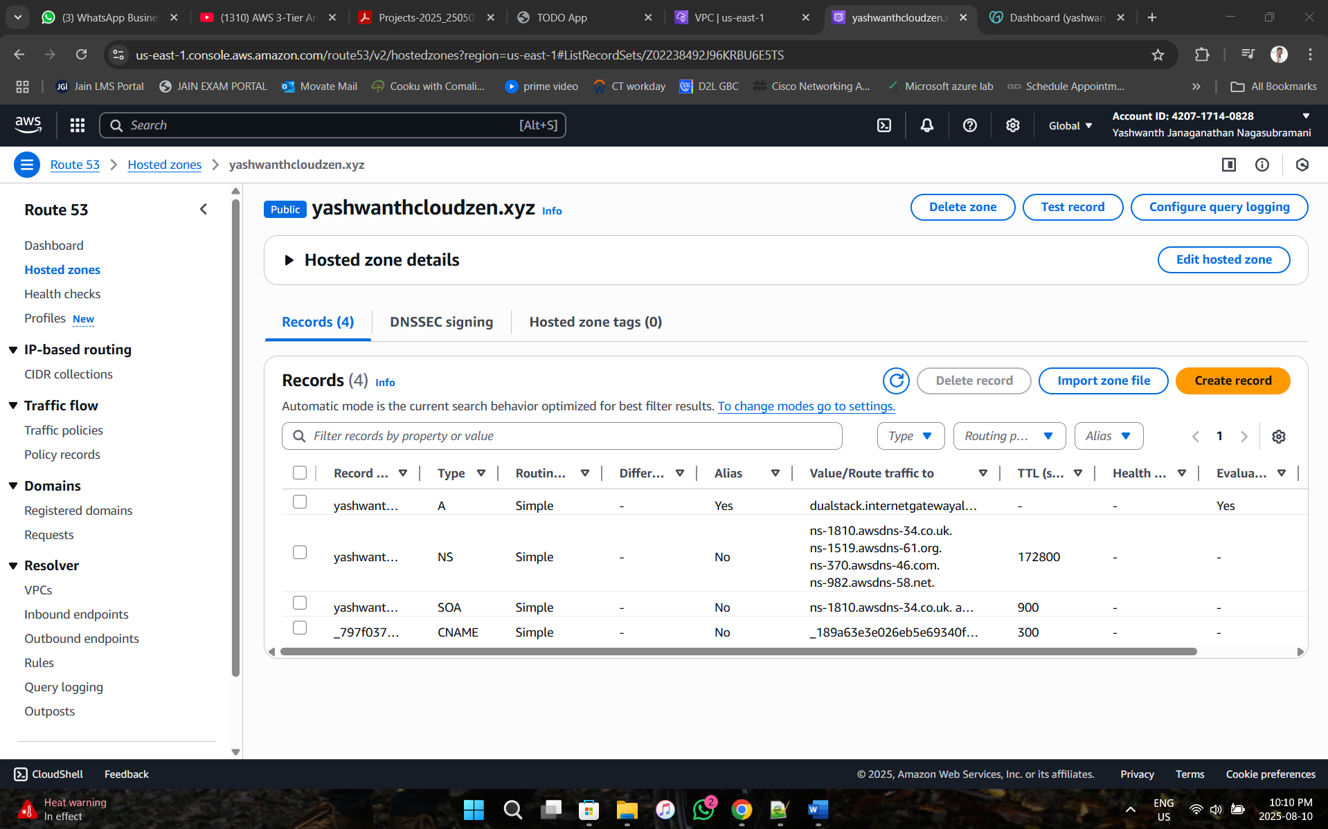

1. **Attach the Route 53 nameservers in Godaddy Domain**

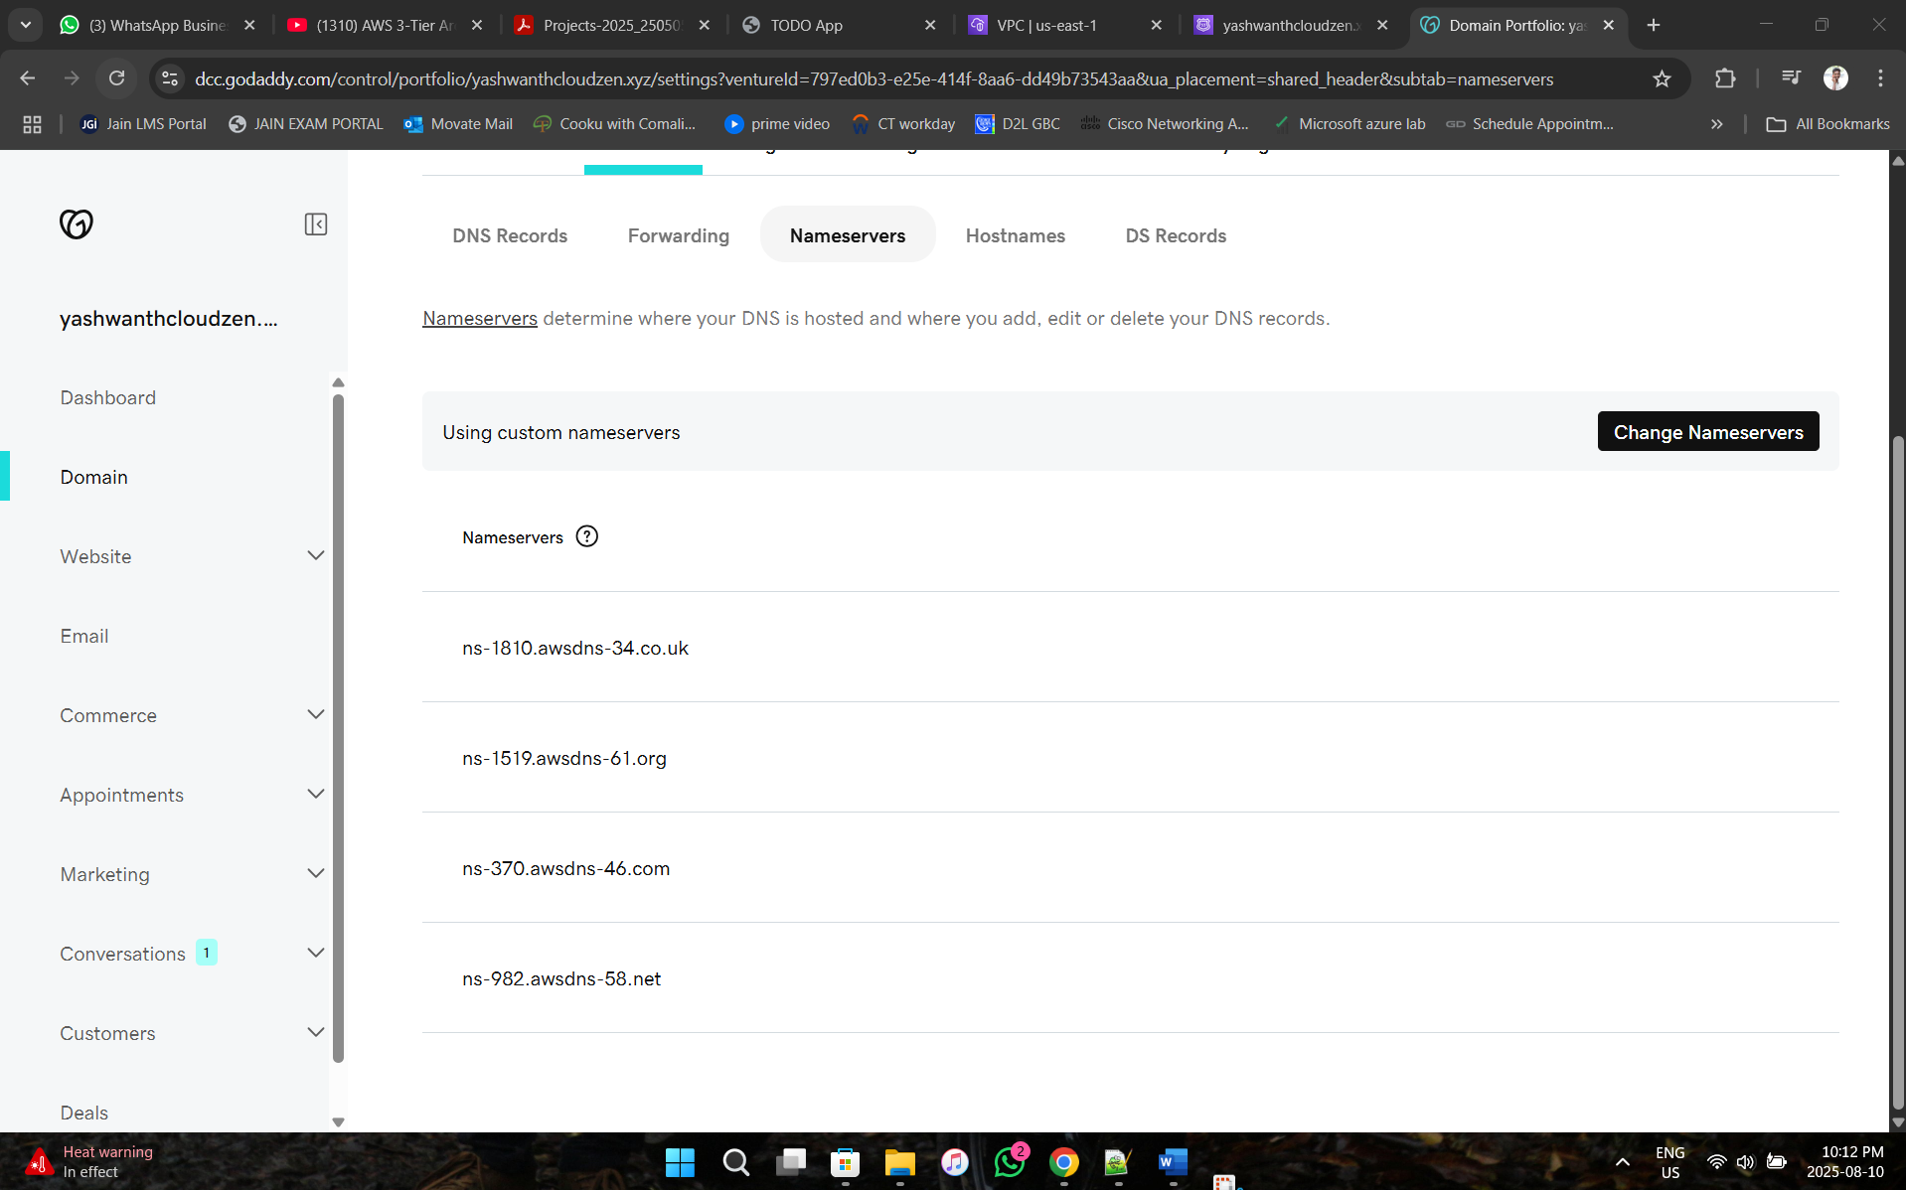

1. **Request a Certificate in Amazon Certificate Manager for the Domain**

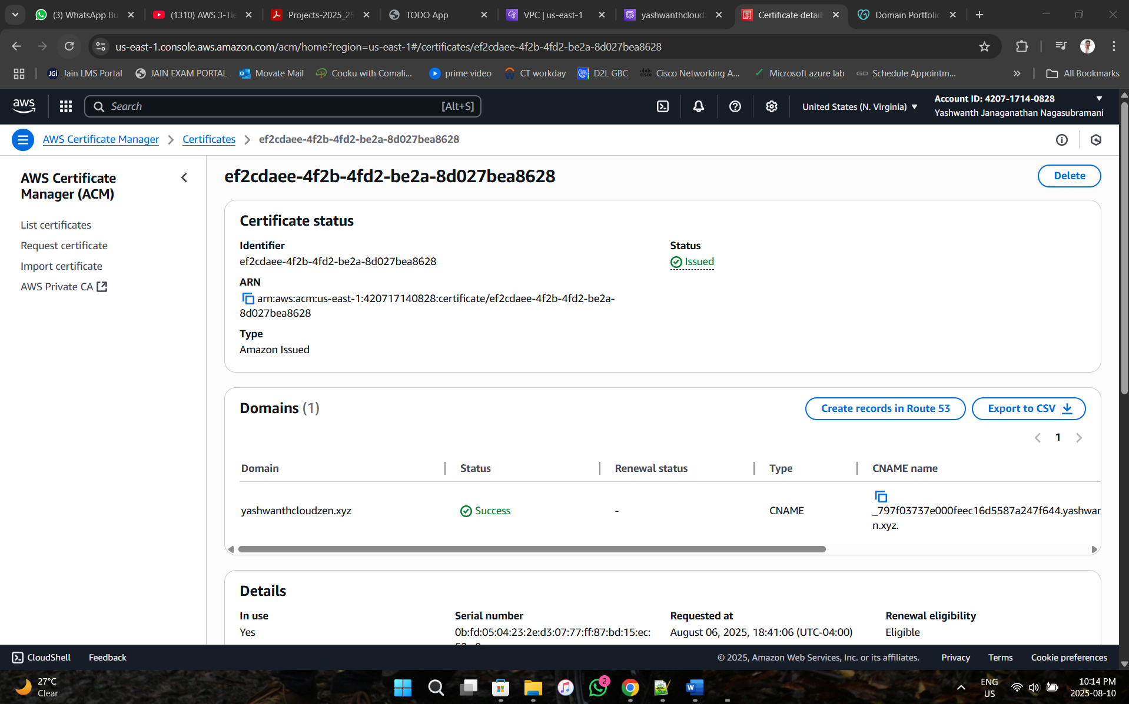

**Phase 5: Database Setup using Amazon Aurora and RDS**

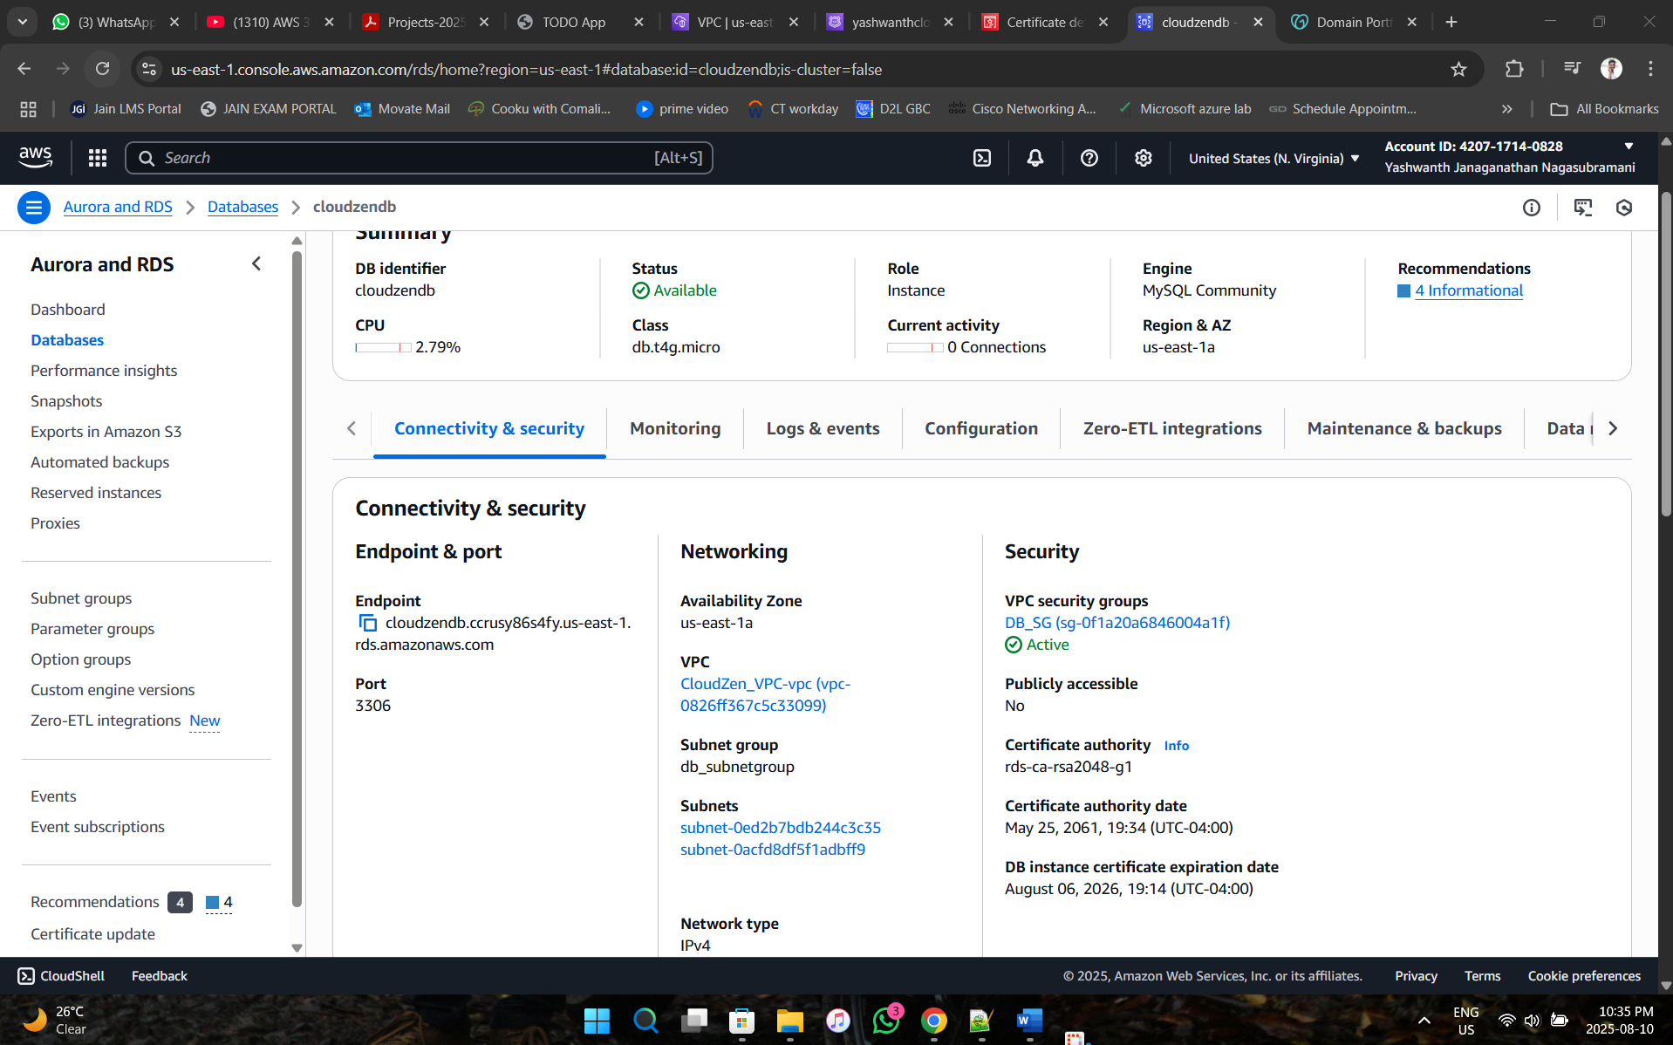

**Phase 6: Create EC2 instances for Webserver and AppServer**

1. **Webserver EC2 instance**

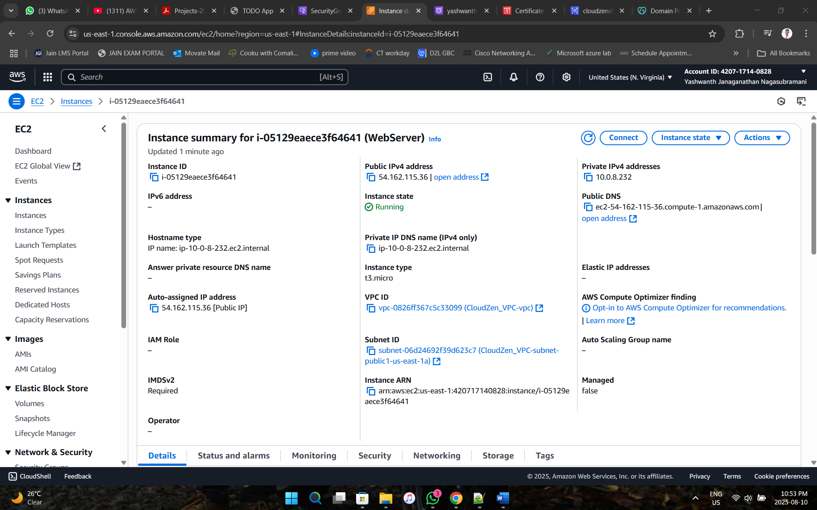

1. **Appserver EC2 instance**

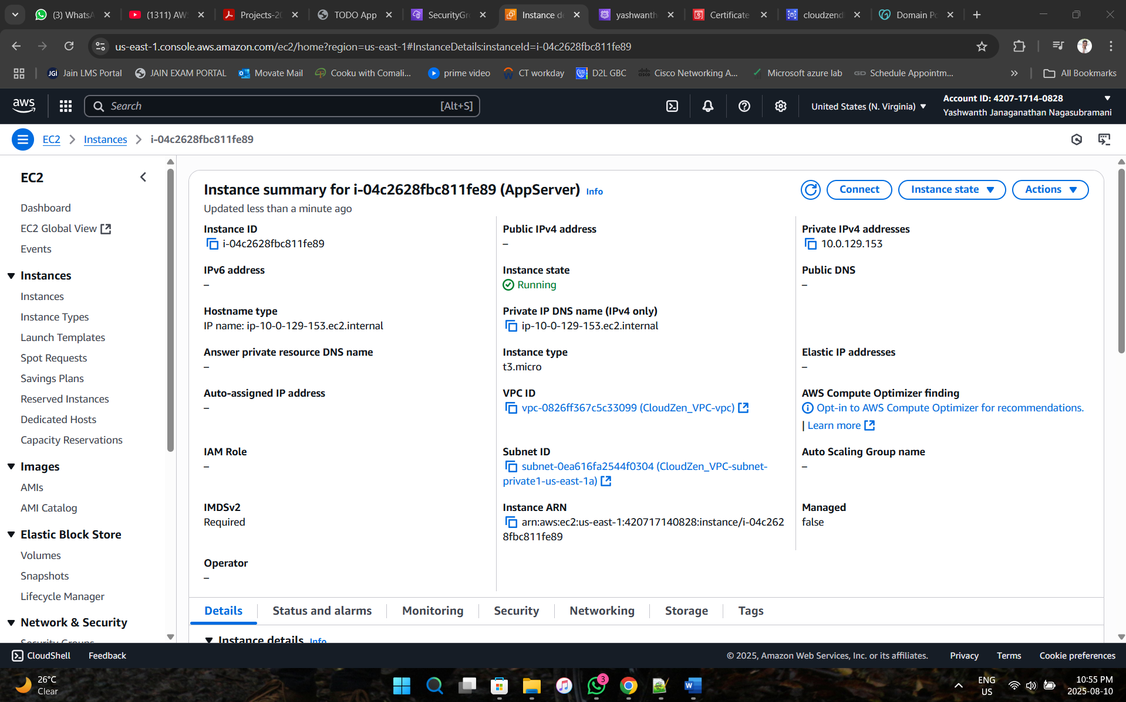

**Phase 7: Connecting Servers using Putty**

1. **Connecting Webserver (ubuntu 10.0.8.232) in putty:**

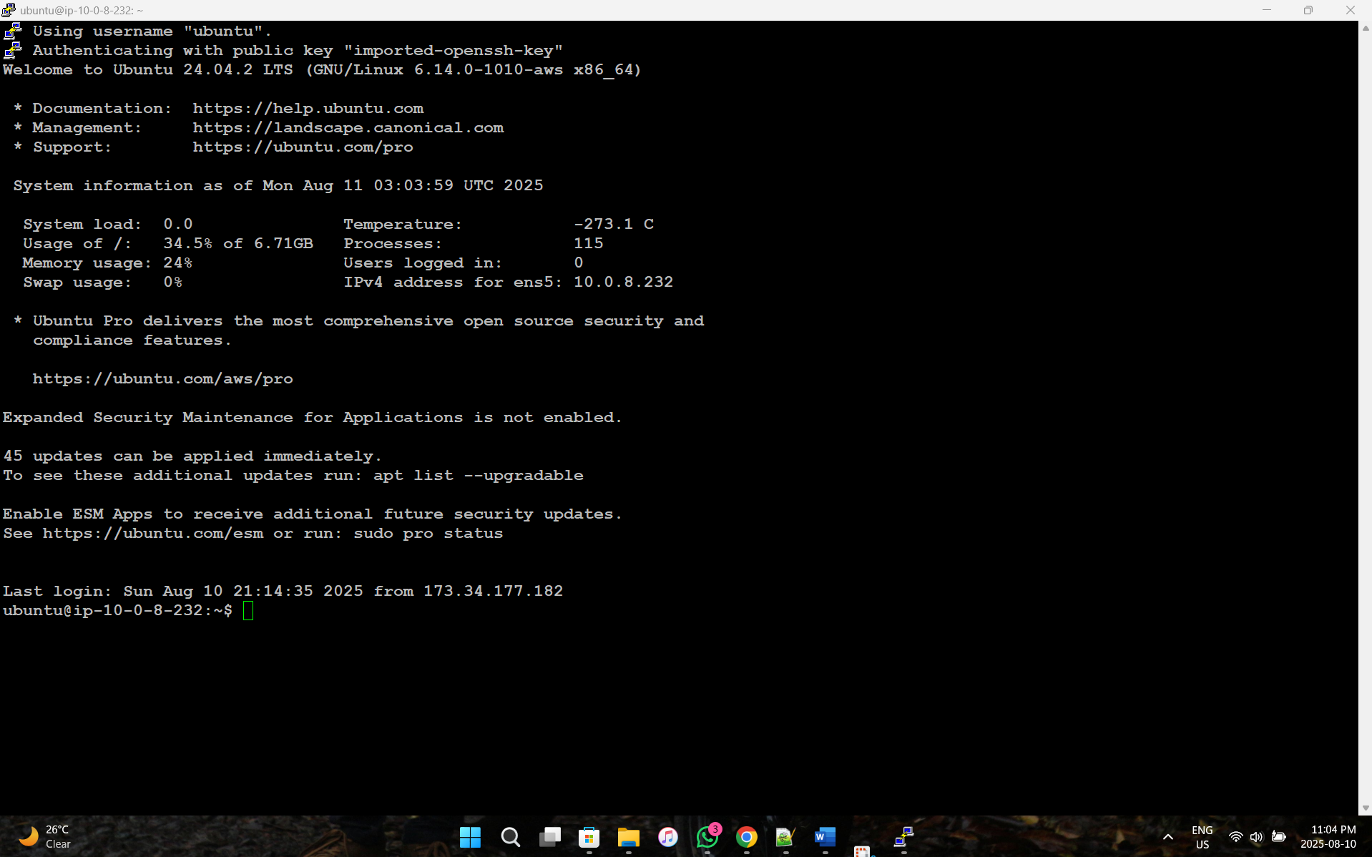

**Installing necessary drivers (nginx, python and mysql)**

1. **Connecting Appserver (Ubuntu 10.0.129.153) via Webserver**

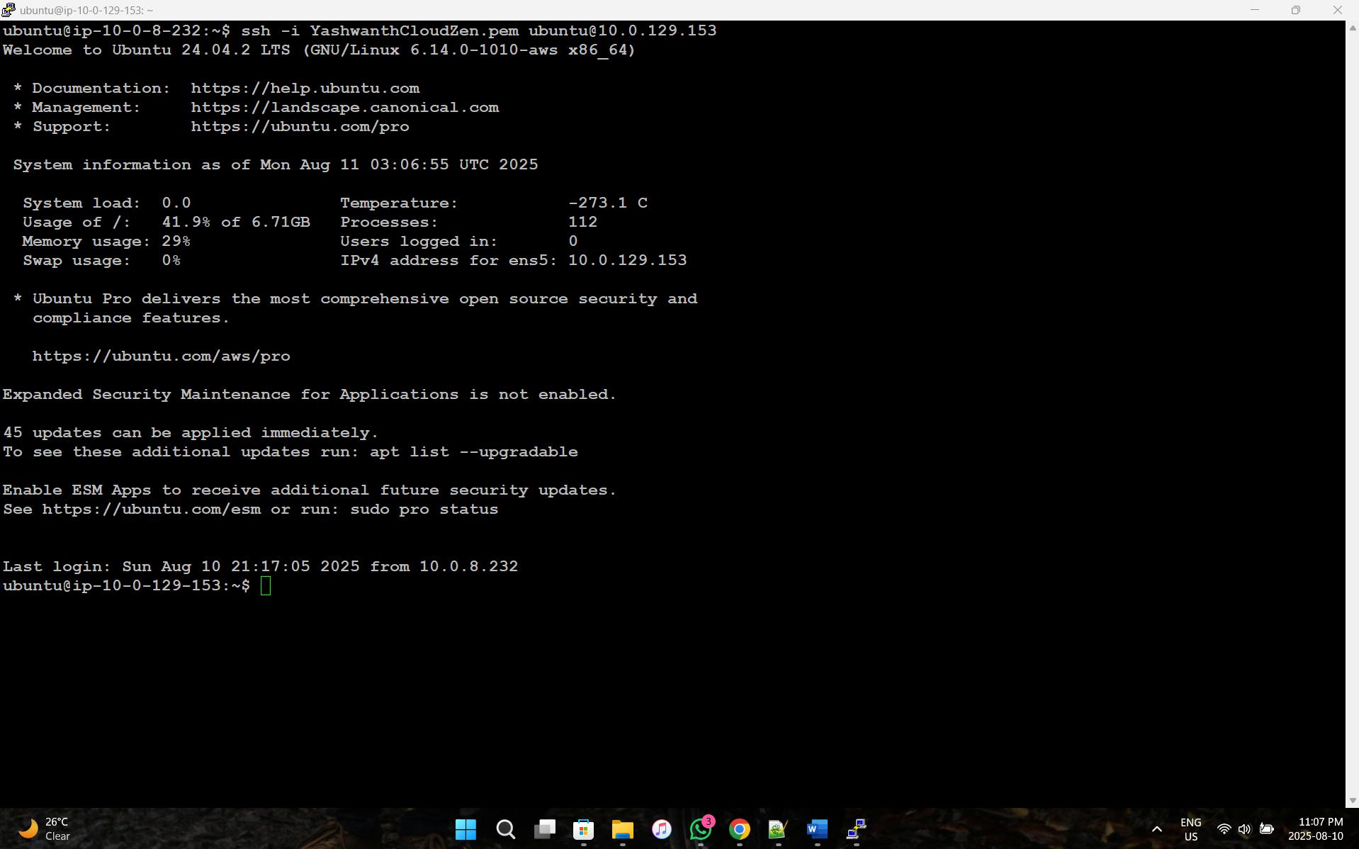

1. **Installing Mysql Database and creating tables named Tasks**

**Commands:**

**To access RDS from App server:**

mysql -u admin -p -h cloudzendb.ccrusy86s4fy.us-east-1.rds.amazonaws.com

**SQL commands:**

show databases; # to show the list of databases

use CloudZenDatabase; #use this database

show tables;

**Create Table:**

CREATE TABLE tasks (id INT AUTO_INCREMENT PRIMARY KEY, description TEXT NOT NULL, is_done BOOLEAN DEFAULT FALSE, created_at TIMESTAMP DEFAULT CURRENT_TIMESTAMP);

see data:

select * from tasks;

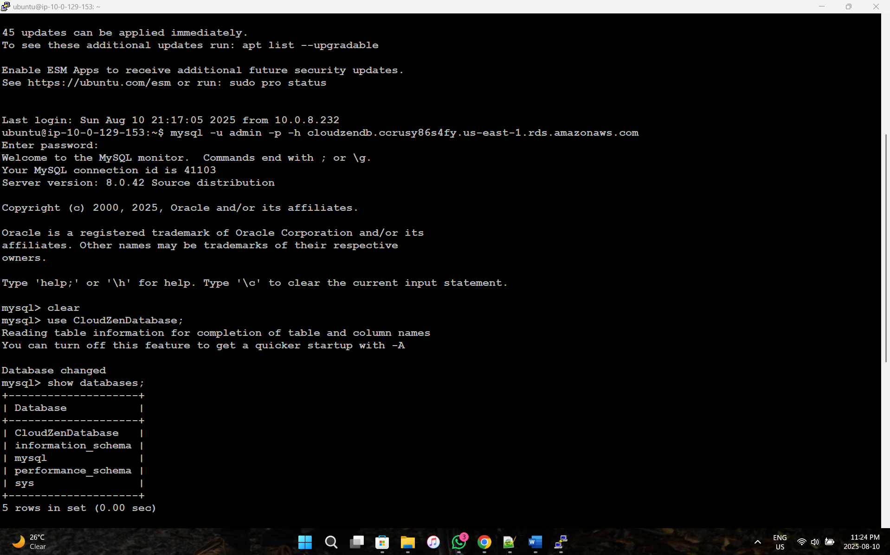

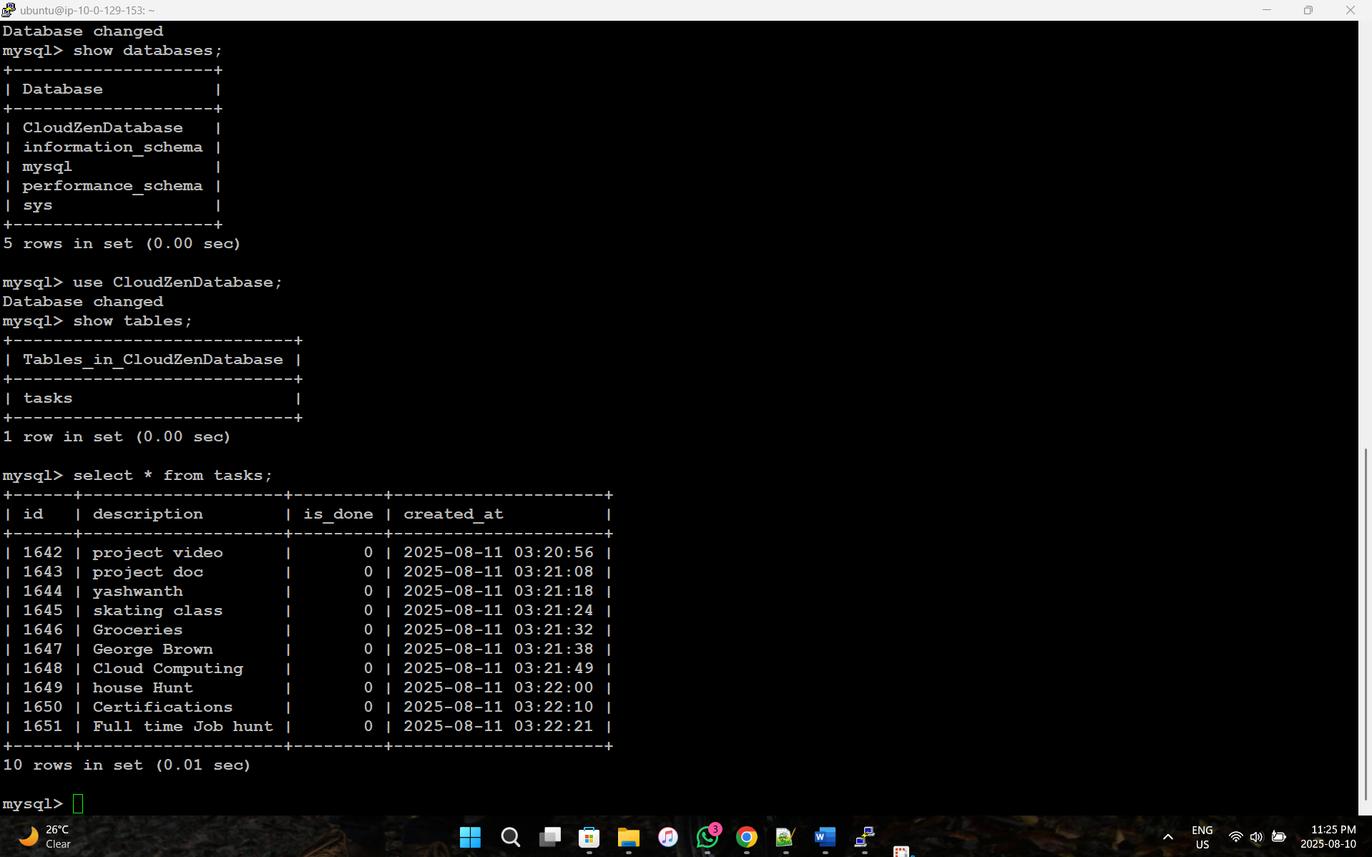

**Phase 8: Deploy Python Script for Flask application and HTML script in Appserver**

Commands:

cd TodoApp

cat app.py # to see python code

cat templates/index.html #to see HTML code

cat run_app.sh #automation script to run python code

cat /etc/systemd/system/flaskapp.service #systemd configuration to start flask app at system start time.

1. **To view Python Script**

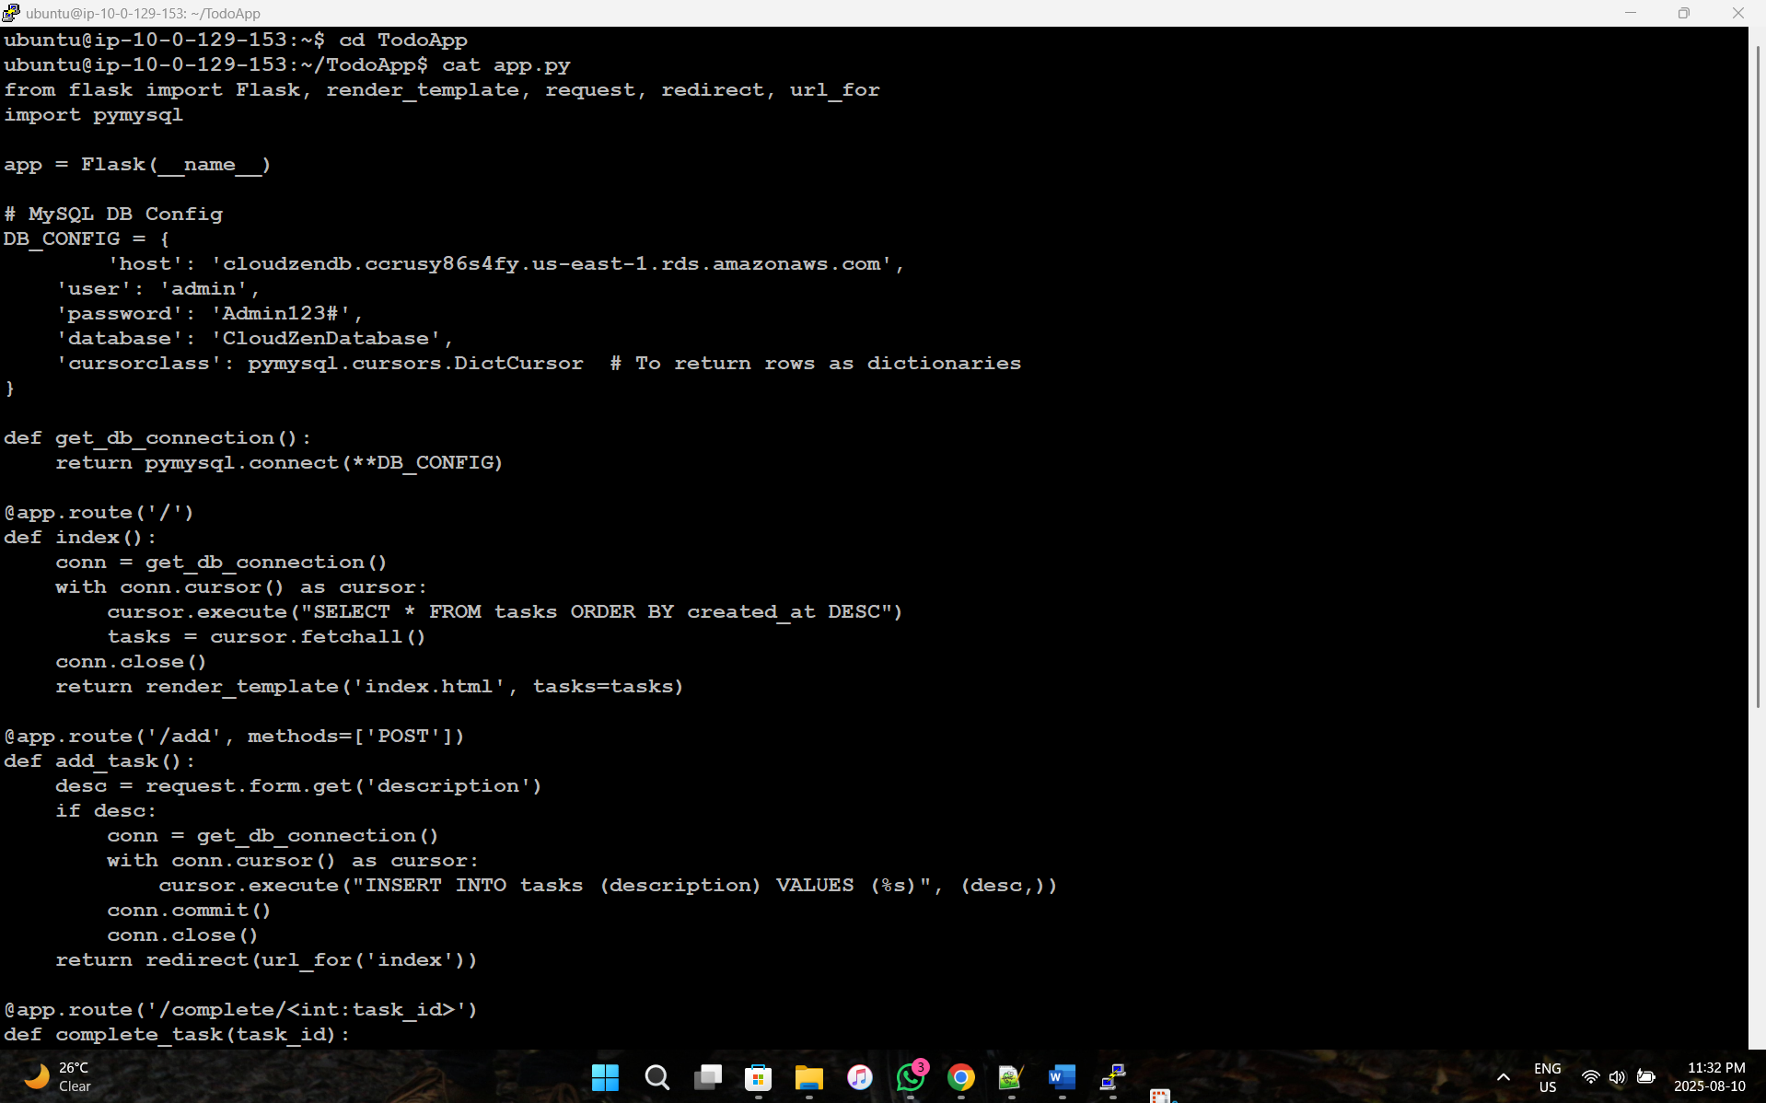

1. **To view HTML code**

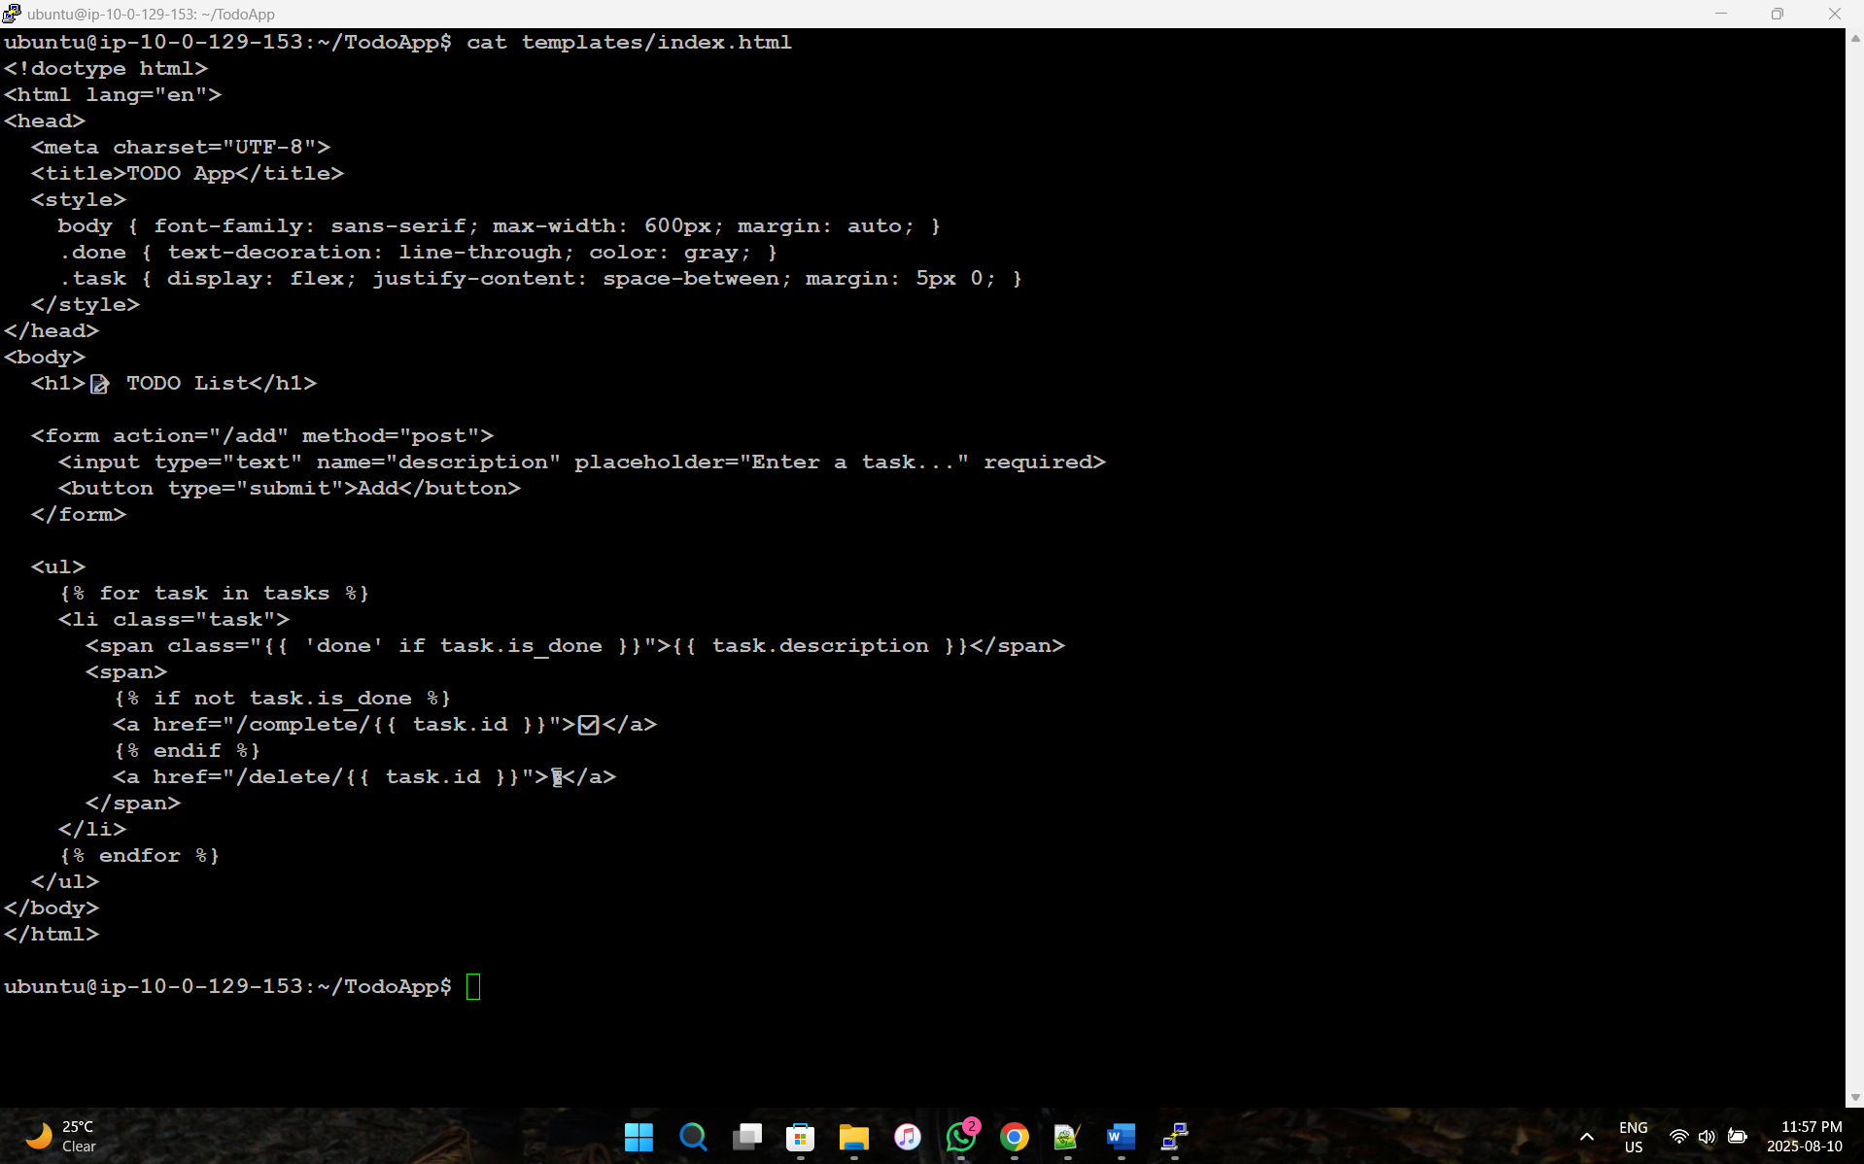

**Phase 9: Create Target Groups and Application Load balancers:**

1. **Create WebServer Target Group**

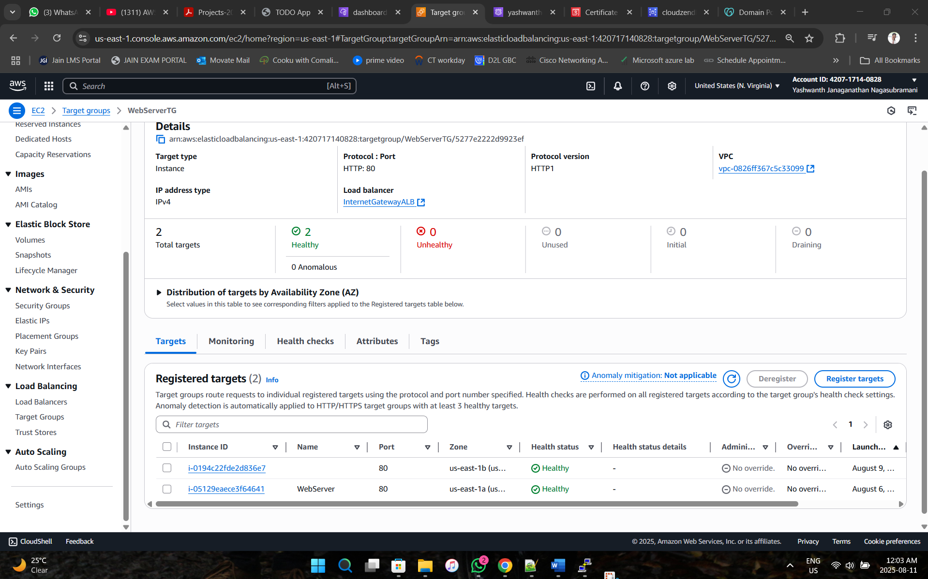

1. **Create AppServer Target Group**

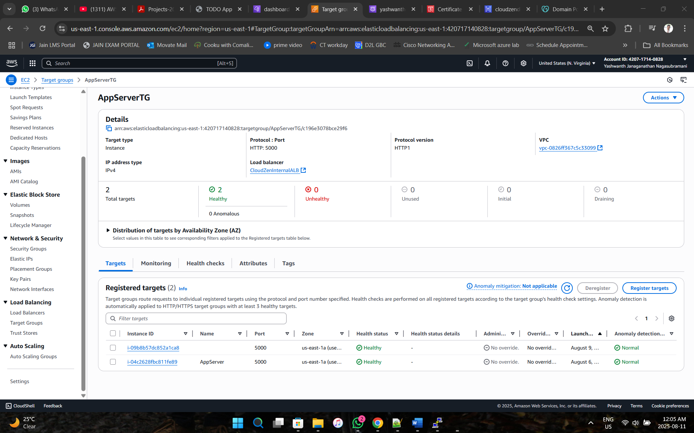

1. **Create Internet gateway Application Load Balancer and attach Webserver Target Group:**

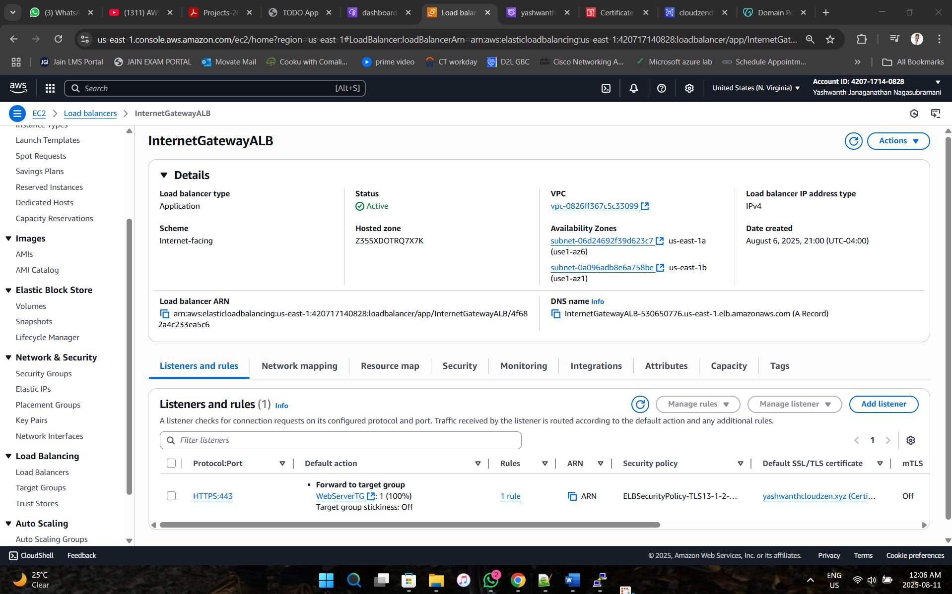

1. **Create CloudZen Internal Application Load Balancer and attach AppServer Target Group:**

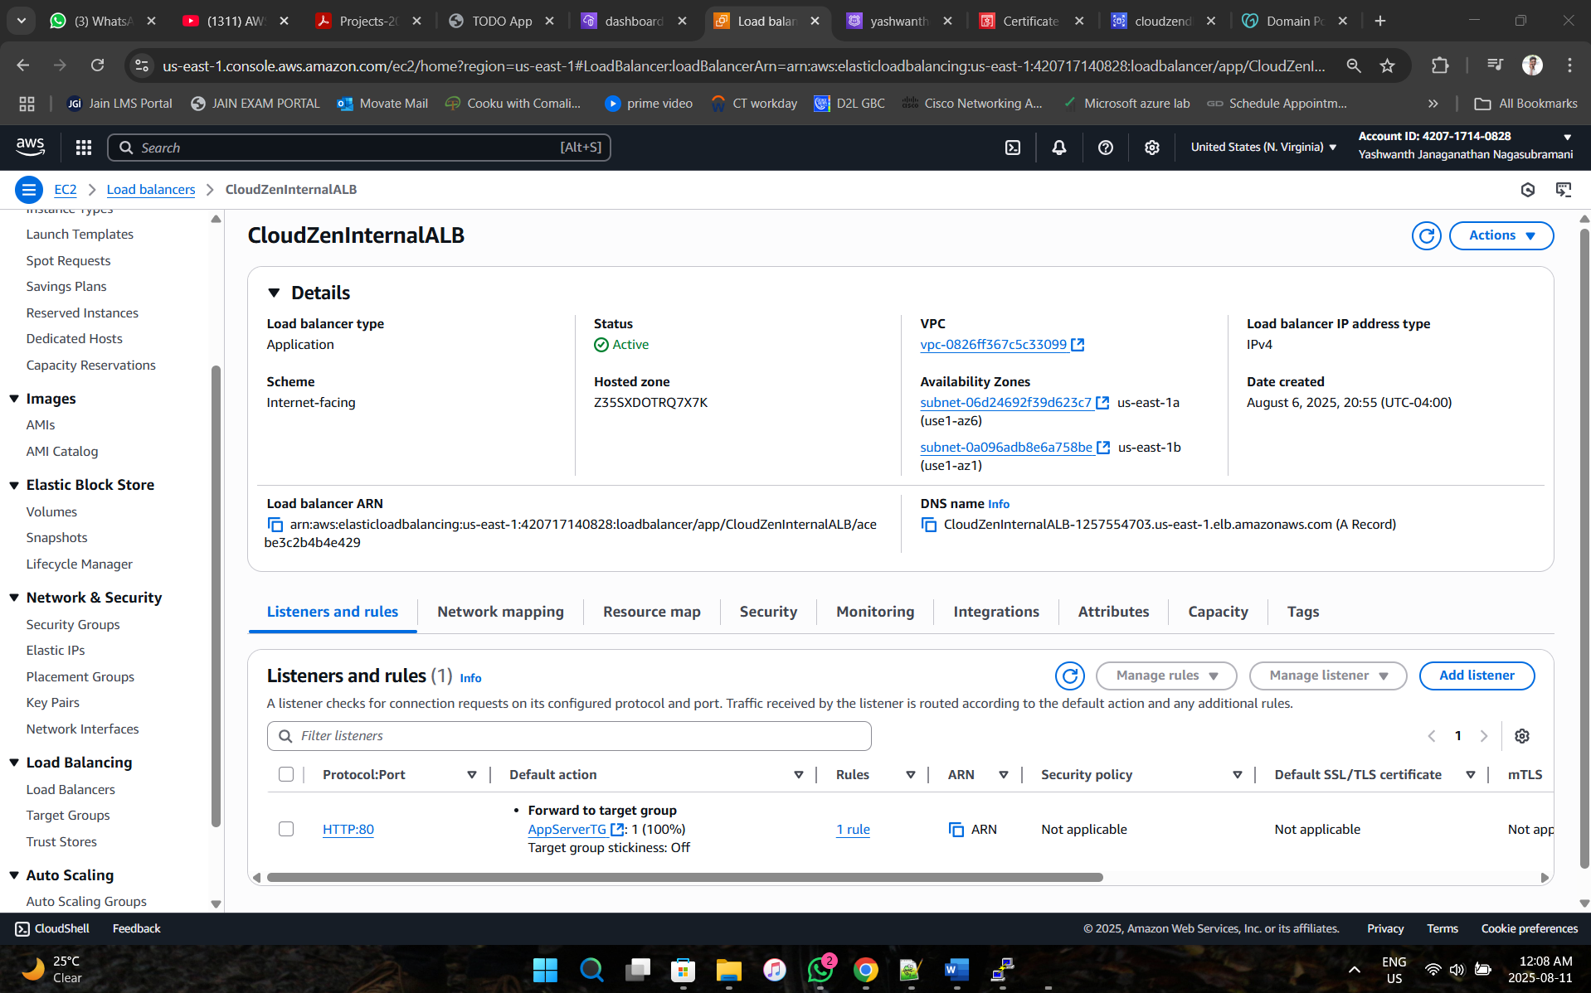

**Phase 10: Implementation of Auto Scaling Group for WebServer and AppServer in Different Region (US-1b)**

1. **Create WebServer AMI**

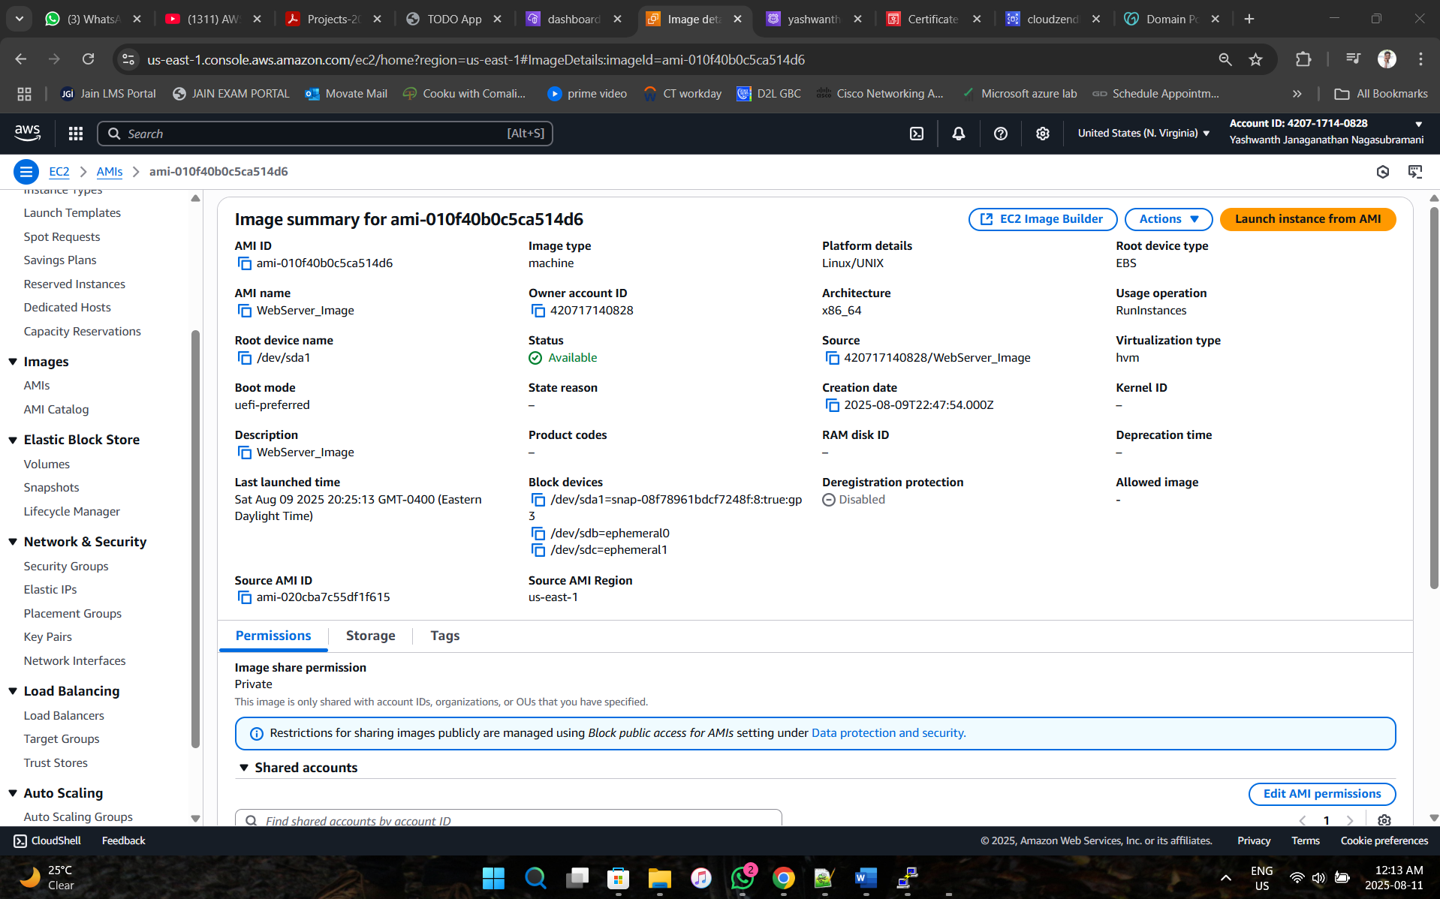

1. **Create AppServer AMI**

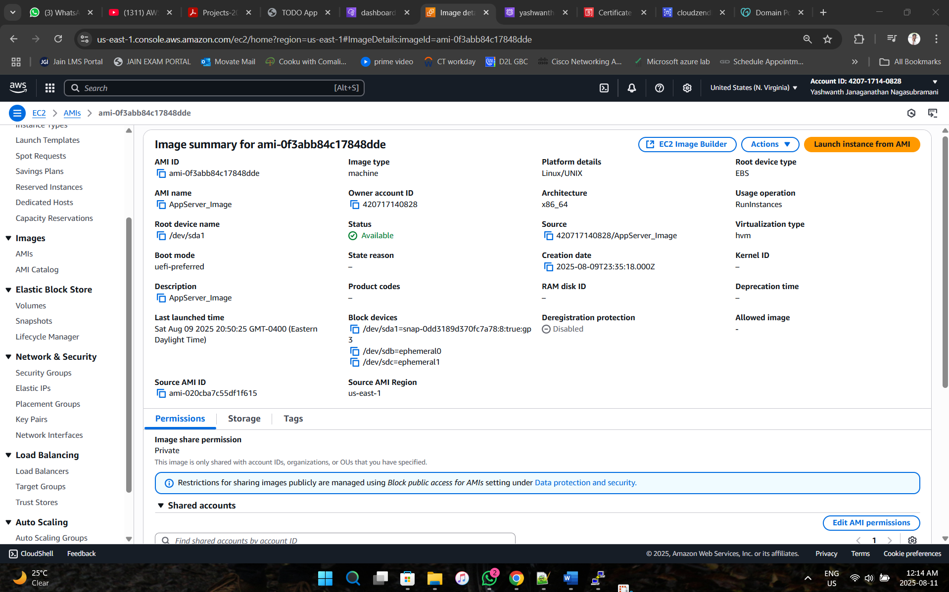

1. **Create WebServer Launch Template**

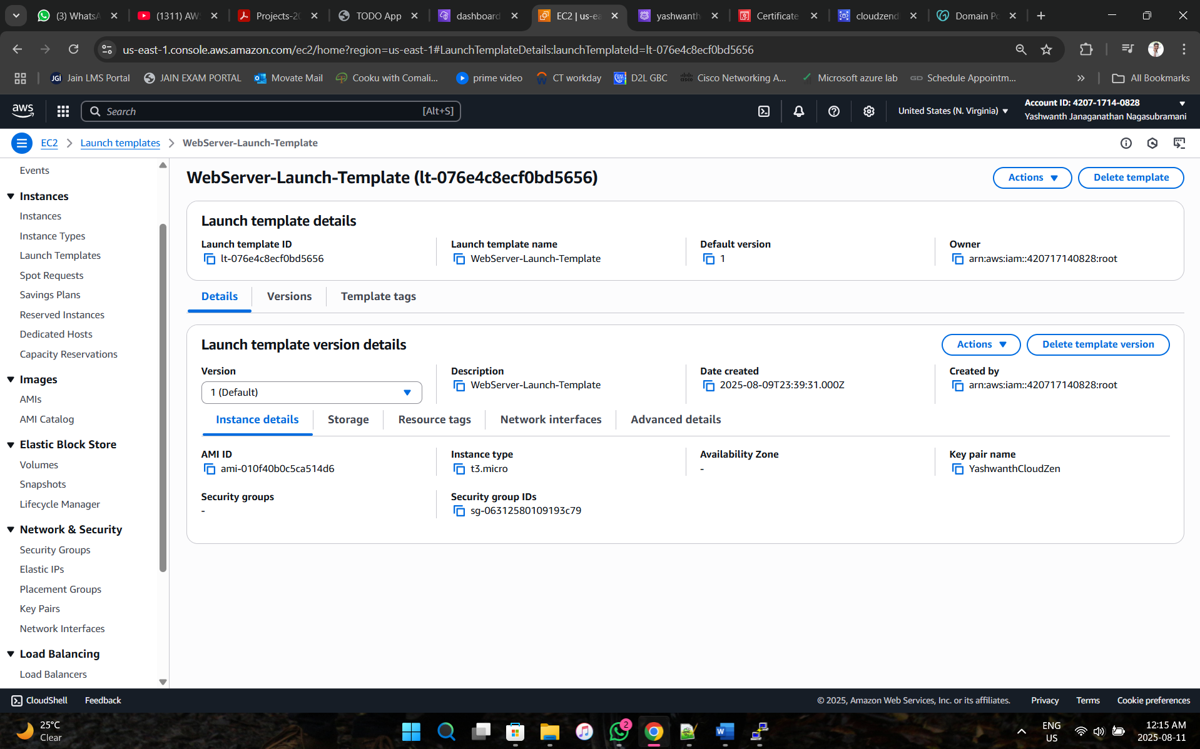

1. **Create AppServer Launch Template**

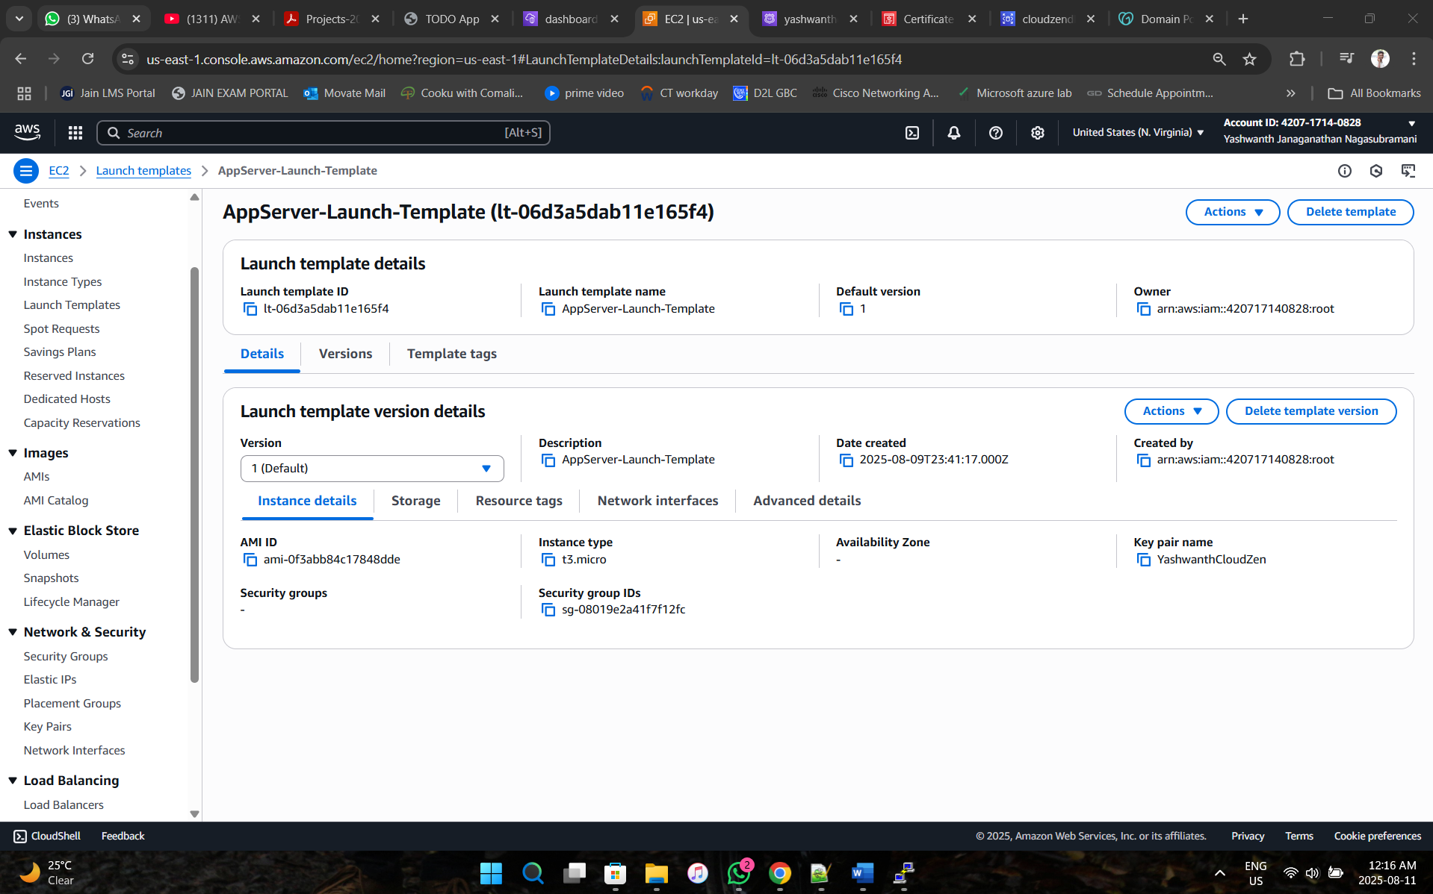

1. **Create Auto Scaling group for WebServer**

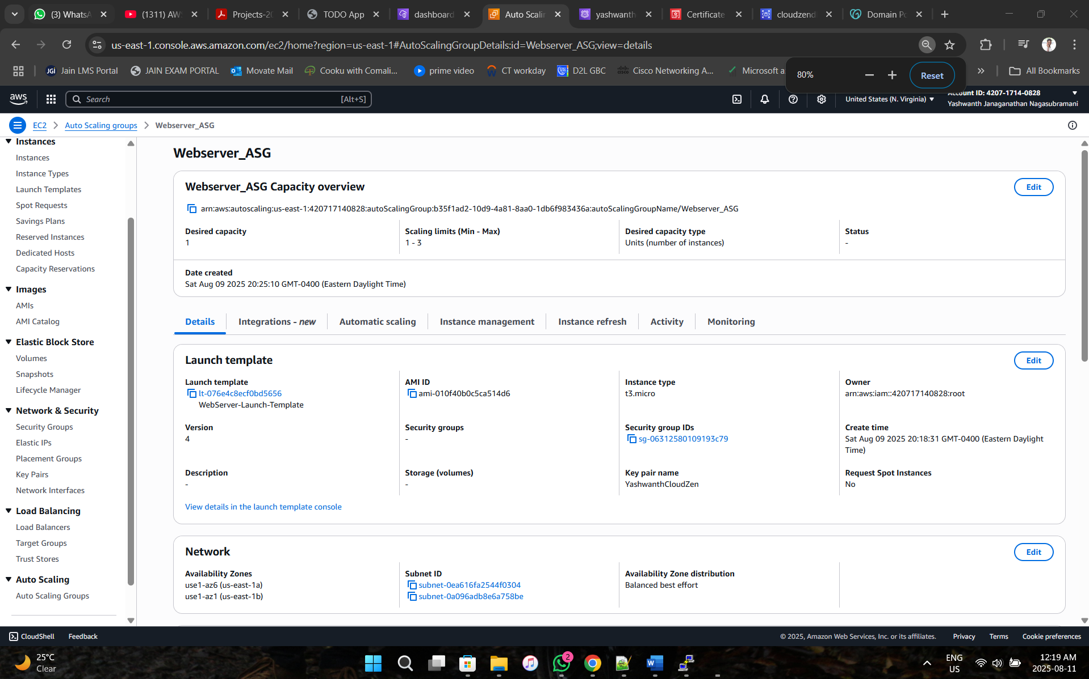

1. **Create Auto Scaling Group for AppServer**

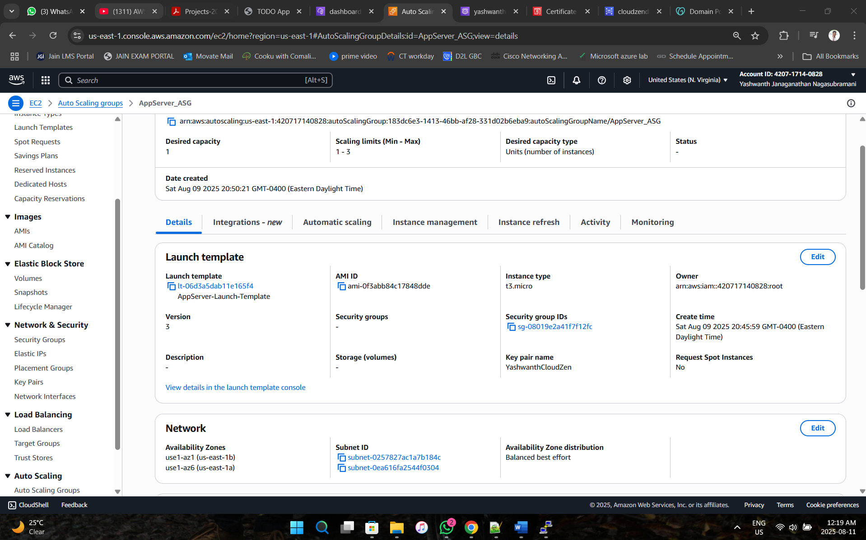

1. **Verification for Auto Scaling groups**

* **1 or More EC2 should be created automatically based on CPU Utilization (50%)**

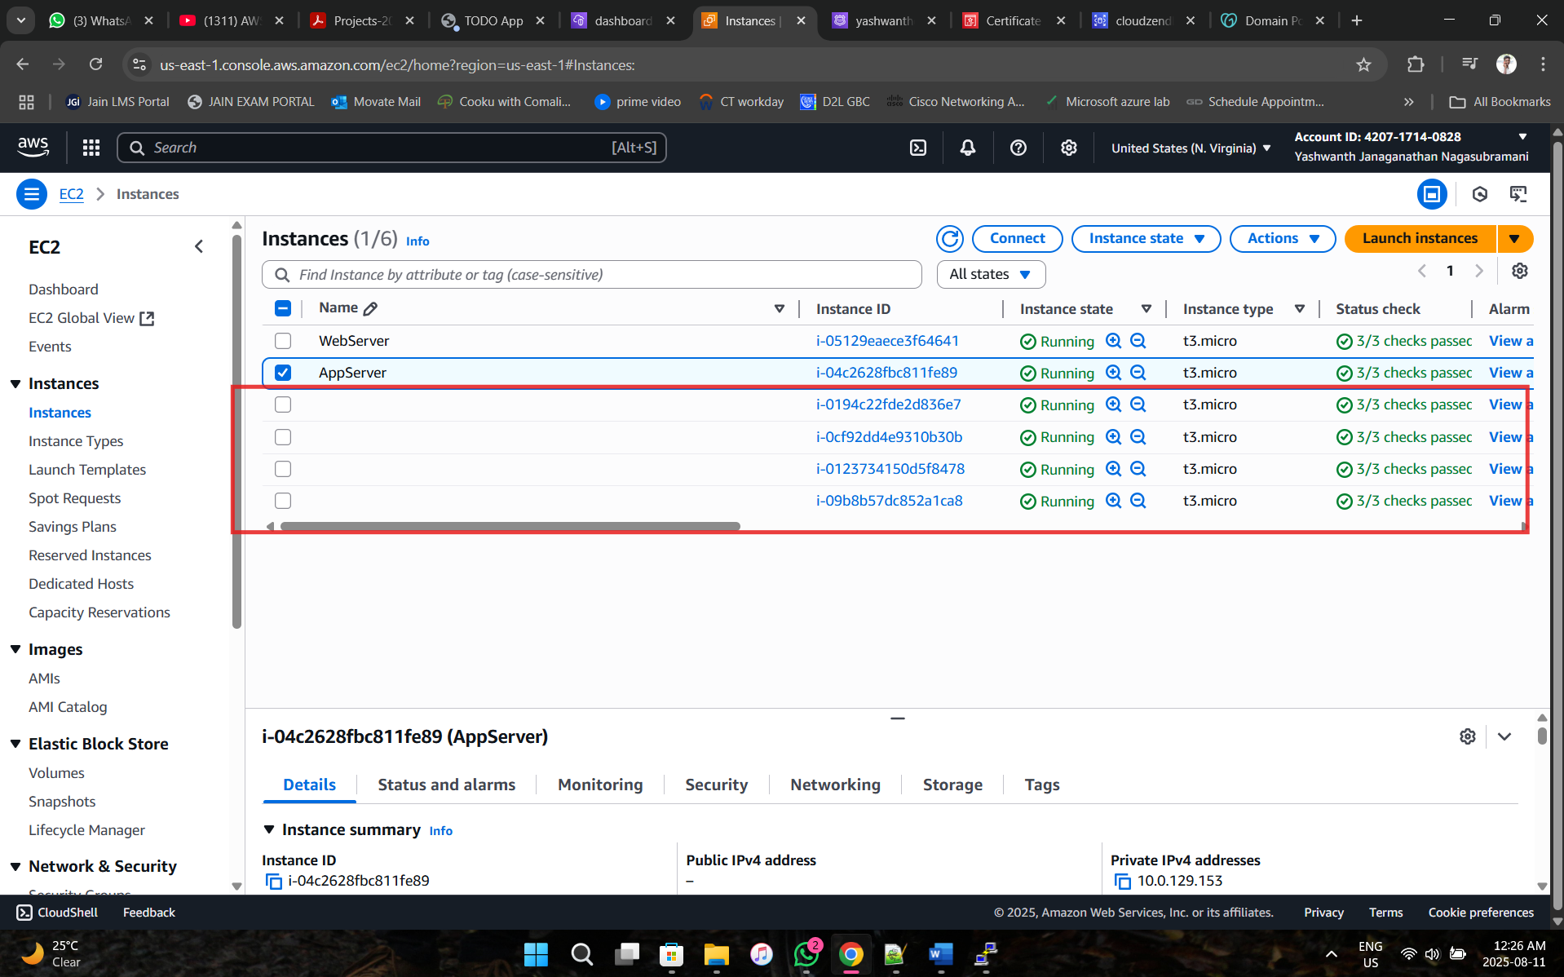

* **WebServer and AppServer Target groups should be healthy**

**WebServer TG:**

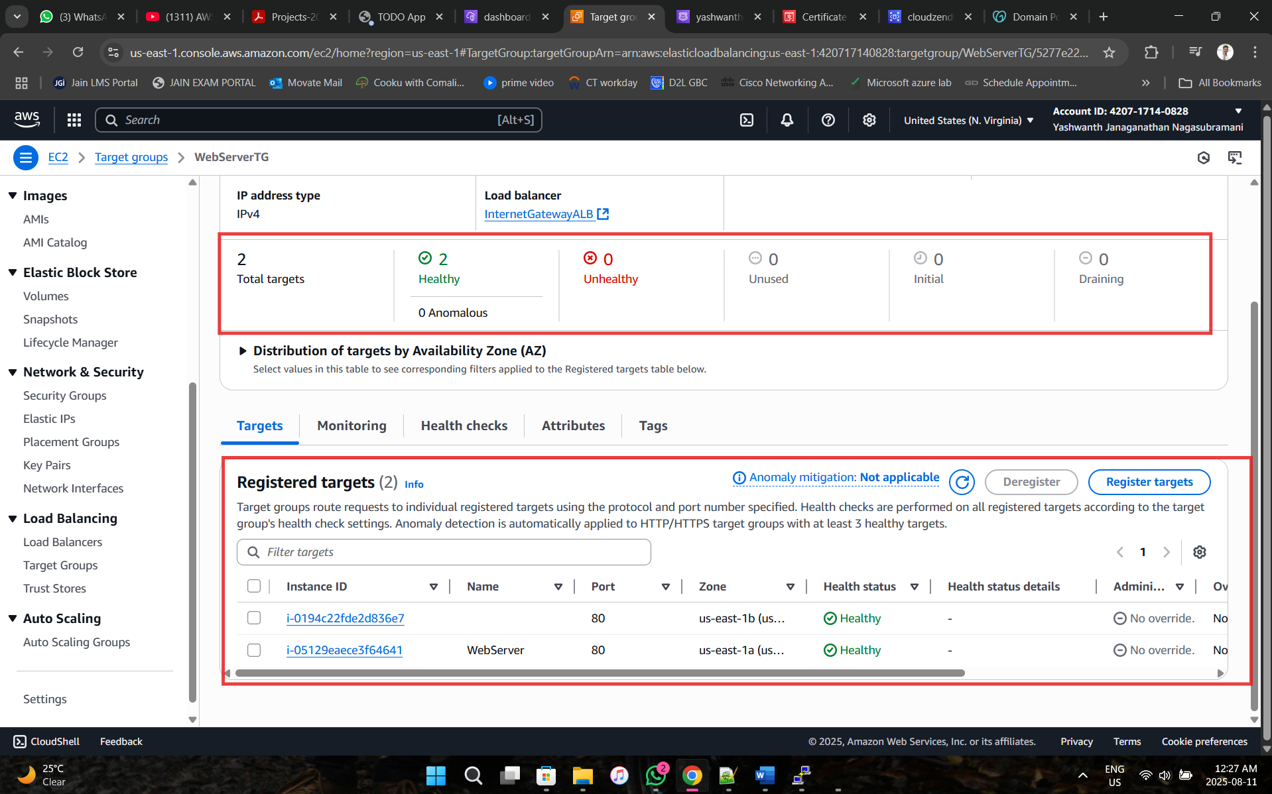

**AppServer TG:**

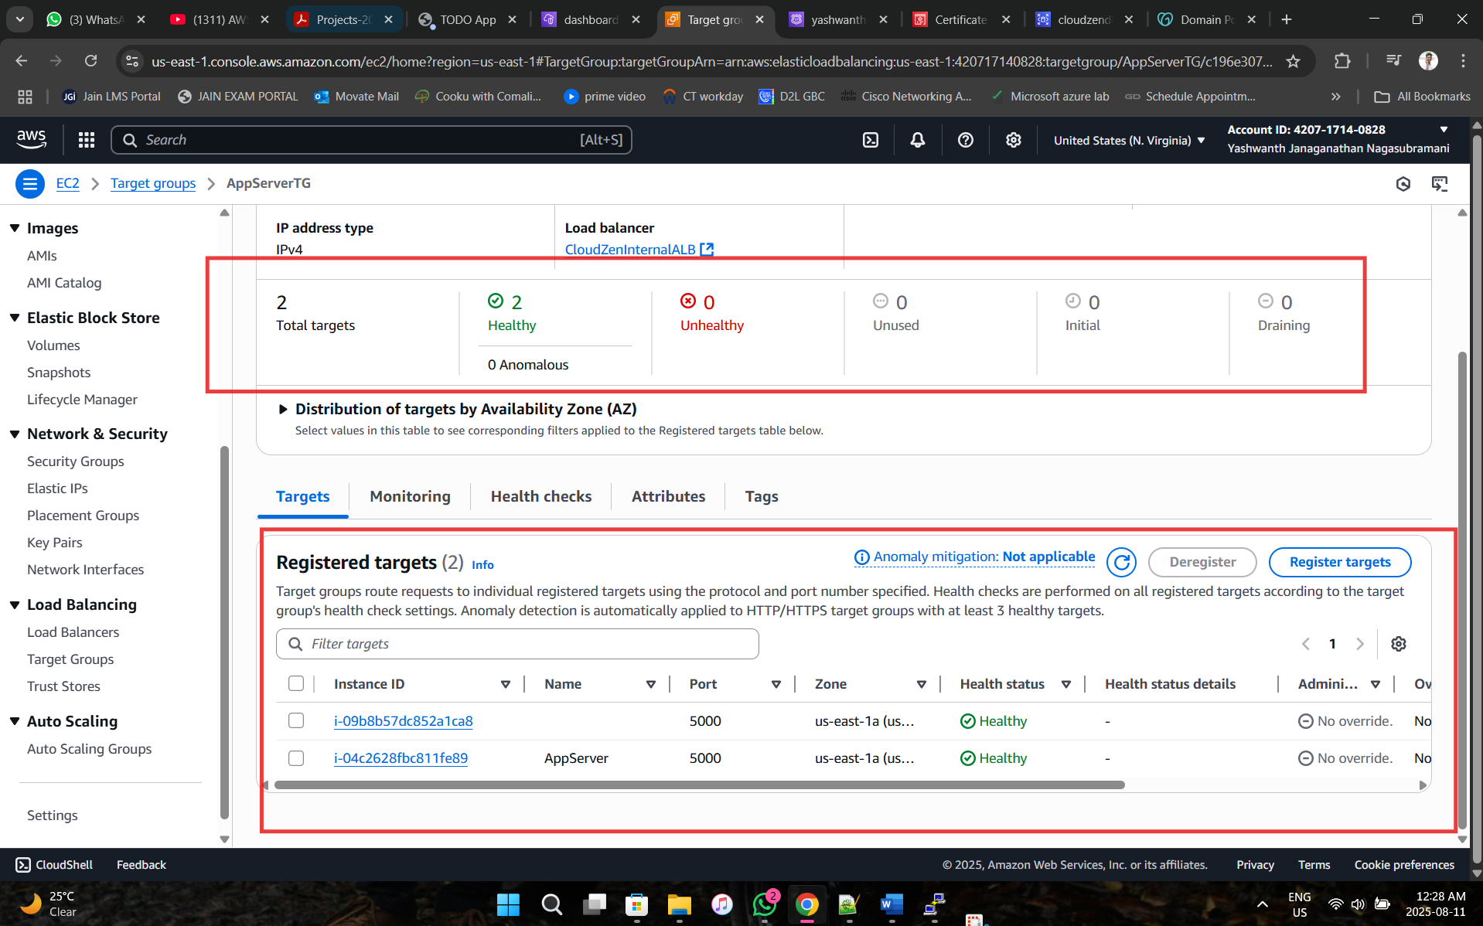

* **The activities of the WebServer and AppServer in Auto Scaling Groups should be successful**

**WebServer ASG activity:**

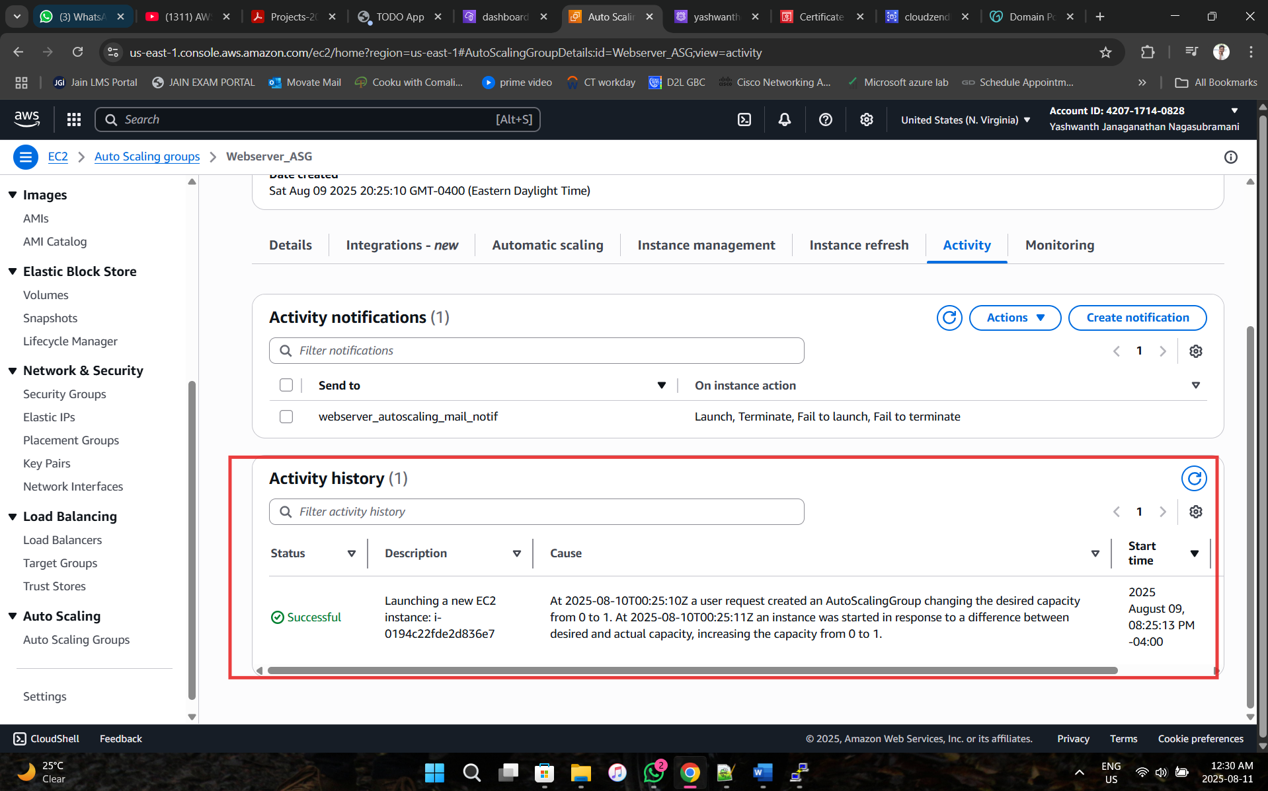

**WebServer ASG activity:**

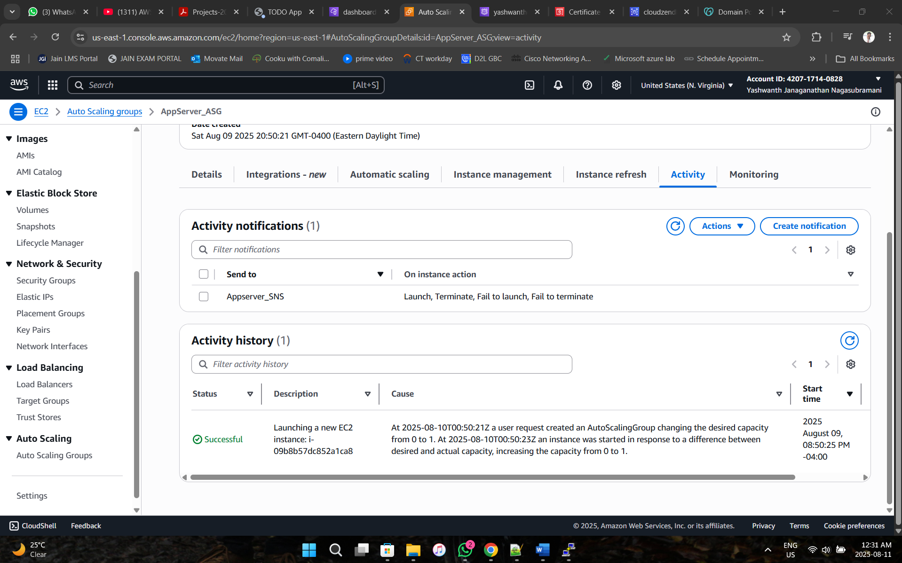

**Phase 11. Verify the website security**

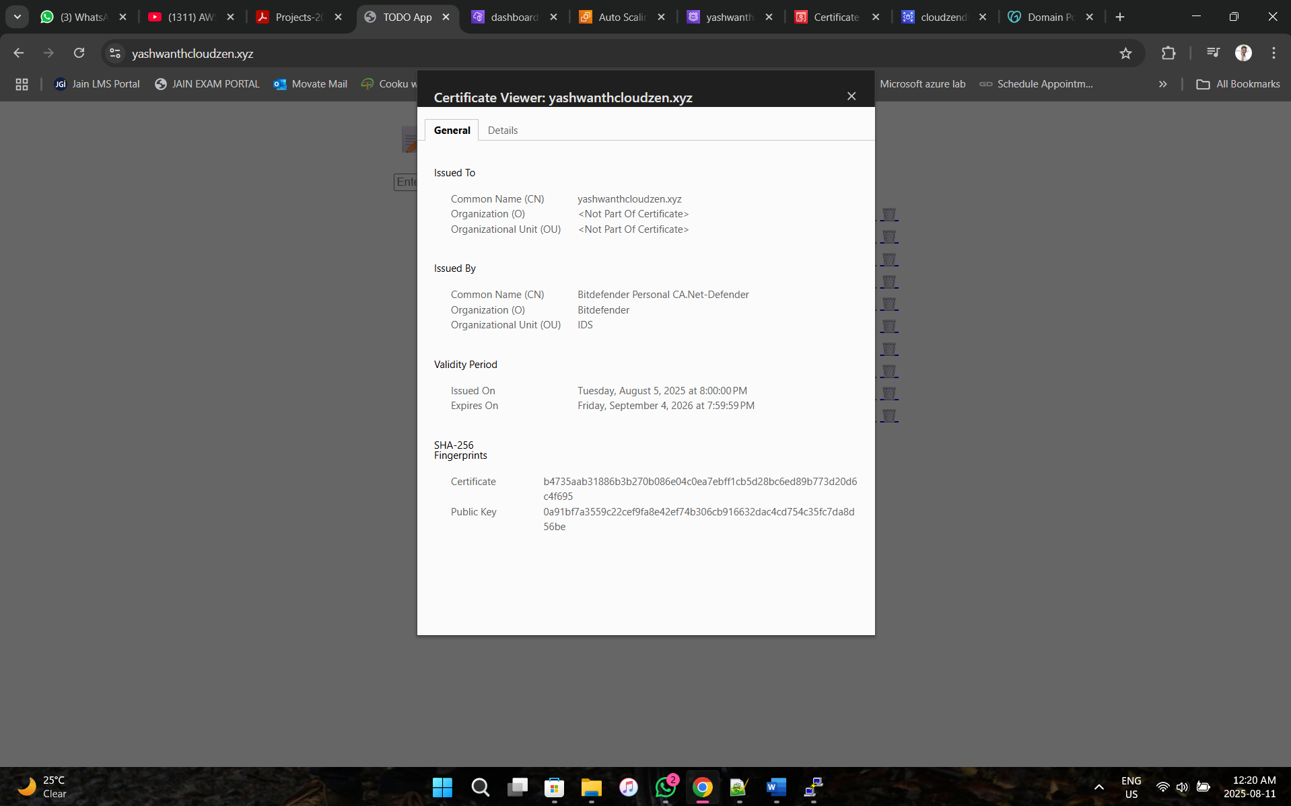

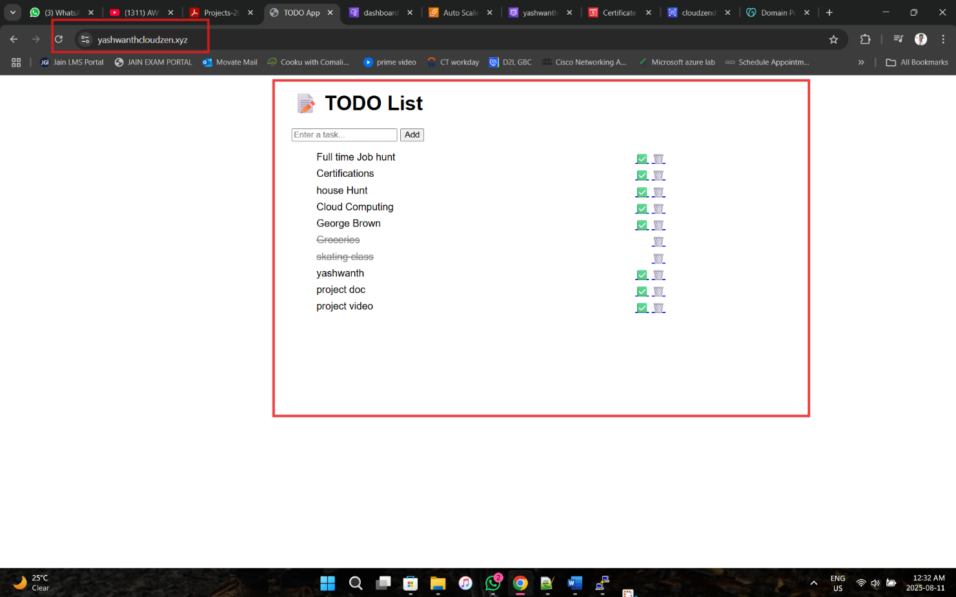**OVERALL OUTPUT:**

**Website Link: https://yashwanthcloudzen.xyz**

**Python Code:**

app = Flask(__name__)

# MySQL DB Config

DB_CONFIG = {

'host': 'cloudzendb.ccrusy86s4fy.us-east-1.rds.amazonaws.com',

'user': 'admin',

'password': 'Admin123#',

'database': 'CloudZenDatabase',

'cursorclass': pymysql.cursors.DictCursor # To return rows as dictionaries

}

def get_db_connection():

return pymysql.connect(**DB_CONFIG)

@app.route('/')

def index():

conn = get_db_connection()

with conn.cursor() as cursor:

cursor.execute("SELECT * FROM tasks ORDER BY created_at DESC")

tasks = cursor.fetchall()

conn.close()

return render_template('index.html', tasks=tasks)

@app.route('/add', methods=['POST'])

def add_task():

desc = request.form.get('description')

if desc:

conn = get_db_connection()

with conn.cursor() as cursor:

cursor.execute("INSERT INTO tasks (description) VALUES (%s)", (desc, ))

conn.commit()

conn.close()

return redirect(url_for('index'))

@app.route('/complete/<int:task_id>')

def complete_task(task_id):

conn = get_db_connection()

with conn.cursor() as cursor:

cursor.execute("UPDATE tasks SET is_done = TRUE WHERE id = %s", (task_id ,))

conn.commit()

conn.close()

return redirect(url_for('index'))

@app.route('/delete/<int:task_id>')

def delete_task(task_id):

conn = get_db_connection()

with conn.cursor() as cursor:

cursor.execute("DELETE FROM tasks WHERE id = %s", (task_id,))

conn.commit()

conn.close()

return redirect(url_for('index'))

if __name__ == '__main__':

app.run(host="0.0.0.0", port=5000, debug=True)

**HTML code:**

<!doctype html>

<html lang="en">

<head>

<meta charset="UTF-8">

<title>TODO App</title>

<style>

body { font-family: sans-serif; max-width: 600px; margin: auto; }

.done { text-decoration: line-through; color: gray; }

.task { display: flex; justify-content: space-between; margin: 5px 0; }

</style>

</head>

<body>

<h1>📝 TODO List</h1>

<form action="/add" method="post">

<input type="text" name="description" placeholder="Enter a task..." required>

<button type="submit">Add</button>

</form>

<ul>

{% for task in tasks %}

<li class="task">

<span class="{{ 'done' if task.is_done }}">{{ task.description }}</span>

<span>

{% if not task.is_done %}

<a href="/complete/{{ task.id }}">✅</a>

{% endif %}

<a href="/delete/{{ task.id }}">🗑️</a>

</span>

</li>

{% endfor %}

</ul>

</body>

</html>